Effects of Computer Generated Images on the Consumer of Visual Mass Media
Emma Carroll
Spring Hill College

Abstract
Consumers are subjected to the use of computer generated images (CGI) in films and more recently in advertising. As the prominence of CGI technology expands beyond films, it is important as a consumer to be aware of the potential effect CGI might have on the consumer of digital visual media. Jean Baudrillard’s theory of hyperreality underpins the primary and secondary research to help explain the effects CGI on consumers’ perception of reality. Three focus groups were conducted on Spring Hill College’s undergraduate population to explore the participants’ thoughts and perceptions about CGI in films and advertising to answer this research question: What are the effects of CGI in digital visual productions on consumers? Thematic analysis and the triangulation method were applied to the qualitative data gathered from the three focus groups. Common patterns included accepting CGI in films more than advertising, confidence in the ability to recognize obvious displays of CGI and expectance of an altered perception of reality when viewing films and advertisements. With the advancement of CGI in advertisements, the participants concluded with the advice to be aware of possible misrepresentation and to explore the idea of implementing regulations including, but not limited to, mandatory disclosures of CGI usage and limits on the amount of CGI when representing a product.

Table of Contents
Introduction 4
Literature Review 4
  - History of CGI 4
  - Hyperreality 5
  - Films 8
  - Advertising 12
Method 17
a. Analytic Strategy 20
- Results 20
    - Theme 1: Acceptance of CGI in films 20
    - Theme 2: Confidence in recognizing CGI in films 22
    - Theme 3: Perception of reality 23
    - Theme 4: Acceptance of CGI in advertisements 23
    - Theme 5: Confidence in recognizing CGI in advertisements 25
    - Theme 6: Expectations of reality in advertisements 25
Discussion 26
Conclusion 28
Future Considerations 30
References 31
Introduction
Computer generated images are growing in the visual media world and are revolutionizing the way films and commercials are created to impact consumers. The invention of CGI technology can be traced back to 1961, and the first motion picture to employ CGI effects was created in 1963 (Lester, 2014, p.364). According to Lester (2014), in 1984, it was revealed how powerful CGI could be after the debut of the movie The Terminator, produced by James Cameron, who is credited with the advancement of computer effects. The film successfully earned high ratings and box office sales. Since then, CGI technology has grown and is not only seen now in most motion pictures, but it has also spread to digital advertising.
The purpose of this research is to discover the effects CGI technology has on consumers. The rationale behind this study is to understand the effects of CGI on the consumer as it is a newer technology and continues to be used in films and more recently in advertising. As a modern form of technology, CGI, with its potential impact, is important for consumers to be aware of as it is becoming more common in digital visual media. Jean Baudrillard’s theory of hyperreality will be used throughout the paper to provide an explanation behind the effects of CGI. Hyperreality explains how, in a highly developed media environment, reality is being substituted with a simulation of reality. The purpose of the study is to answer this research question: What are the effects of CGI in digital visual productions on consumers?
Literature Review
History of CGI
Computer generated images (CGI) started arising with the popularity of science fiction films. Although in the early stages of CGI technology it was obvious to the consumer that there were added effects to the films, during the 1980s, the public’s knowledge of computers was limited. According to Singh (2007), “Public exposure to computing was generally confined to the video game” (para. 6). The graphics were highly pixelated, which led to the audience’s skepticism of CGI in films. Special effects were originally obvious, but as CGI continues to grow, it is becoming harder for the consumer to distinguish the real life shots from the CGI edits. Whether or not CGI should be inconspicuous has been the ongoing struggle for Hollywood filmmakers (Singh, 2007). In 1982, TRON heavily relied on CGI for the film but did not have a great success rate. The audience was aware of the added technology and did not think it was necessary. James Cameron paved the way for successful CGI techniques as his movies strived to use CGI in a more convincing way. Singh (2007) said, “In 1989, when James Cameron was making The Abyss, CGI technology was at a point in its development where it could provide a sufficient realism” (para. 9). The CGI software was advancing rapidly allowing producers to have more control over different ways to intertwine CGI with the real live shots. The use of CGI allows the possibility of any idea from the producer’s imagination to come to life. With the use of digital effects, characters, scenery, and the narrative can be transformed. However, the interpretation of the meaning of the narrative can be altered through technology changing the ways consumers view media. Queau (1998) suggests man’s true reality is to go beyond the world and change it. If mankind has the opportunity to explore science and technology, including the technology of CGI, it is their right to utilize and expand it.
Hyperreality
Postmodernism is an era where style and spectacle are prominent. The origins of the Postmodern age are debated. According to Felluga (2011),
“Many date postmodernity from the sixties when we witnessed the rise of postmodern architecture; however, some critics prefer to see WWII as the radical break from modernity, since the horrors of nazism (and of other modernist revolutions like communism and Maoism) were made evident at this time.”
The advancements of sound, color and special effects in films sparked the shift from Modernism to Postmodernism. Special effects are often referred to as being Postmodern because they are designed to create something spectacular. According to Strinati (1993), “The idea is that popular cultural signs and media images increasingly dominate our sense of reality and the way we define ourselves and the world around us.” Visual effects are becoming more important than the narration, and these effects can influence the meaning of films and advertising. In the Postmodern era, individuals are going to be influenced by technology whether the individual is aware or not. Mirzoeff (1998) says, “While print culture is certainly not going to disappear, the fascination with the visual and its effects that was a key feature of modernism has engendered a postmodern culture that is at its most postmodern when it is visual” (p.4). Postmodernists, more than Modernists, were aware of the infiltration of visual media in everyday lives. The media saturated environment was unavoidable due to the love and fascination with technology therefore creating this new age. Ryu (2007) suggests “Digital visual effects are postmodern objects themselves, in terms of their characteristic feature as media, in that they are created by the hybridization between cameras and computers” (p. 32). Digital visual effects are considered as media due to the enhancement of film with computer technology. This hybrid adds to the already media saturated environment noted by Postmodernists.
Jean Baudrillard originated the idea of hyperreality. Hyperreality occurs when the distinction between the real and the imaginary is blurred. Baudrillard believed, “People live in the “hyperreality” of simulations in which images, spectacles, and the play of signs replace the concepts of production…” (Kellner, 2015). In the Postmodern world, people are willing to abandon the experiences of reality and replace them with simulacra. A simulacrum is what is left after the distinction between reality and its representation disappears. Baudrillard, aware of the influence of simulacra, found that reality does not have any meaning anymore because the meaning is no longer important to the individual. For example, Baudrillard says, "The territory no longer precedes the map, nor does it survive it. It is nevertheless the map that precedes the territory—precession of simulacra—that engenders the territory" (Felluga, 2011). According to Baudrillard, the territory used to precede the map, but it has shifted to where the map precedes the territory. The territory is no longer important because the map has replaced all facets of the territory with icons that are substituted for reality and become more important than the reality. For example, the weather channel and weather applications display icons to represent weather conditions. An icon of a cloud is a perfect, white, scalloped oval. When the icon of a cloud is displayed, it tells the consumer to expect cloudy weather. However, when looking outside, there is not an image of a perfect, white cloud icon in the sky, but the consumer already knew to expect clouds because of the icon. The representation of a cloud used by weather reporters has replaced the consumer’s knowledge of a cloud and the consumer accepts it as the reality. The signs of the real are becoming more important than the real itself. With simulacra being unavoidable, people “flee from the ‘desert of real’ for the ecstasies of hyperreality and the new realm of computer, media and technological experience” (Kellner, 2015). The experiences felt watching entertainment are better than the experiences going through life, which can explain the willingness to let simulacra replace reality. Baudrillard’s famous example of Disneyland explains simulation and simulacra. It is supposed to be an imaginary world, yet visitors go in and think this is what the perfect American world is supposed to be like. Nostalgia for the past enables individuals to reimagine what the perfect life used to be and project that into the present world. Disneyland is represented as a children’s place and that adults are everywhere else outside of the park. Baudrillard explained this by saying,
“It is meant to be an infantile world, in order to make us believe that the adults are elsewhere, in the ‘real’ world, and to conceal the fact that real childishness is everywhere, particularly among those adults who go there to act the child in order to foster illusions of their real childishness” (1988, p. 171).
Adults go to Disneyland to reimagine their childhood memories but end up replacing those memories with false illusions. The individual is accepting the altered reality. It is becoming harder to distinguish what is real and ultimately harder to prove the real. The real is being replaced by something without “origin or reality” (Ryu, 2007, p. 32). Baudrillard creates the term simulacrum to describe an image that does not represent anything real, yet the consumer believes it to be real. Hyperreality can explain the phenomenon the audience is undergoing when absorbing digital visual media, particularly films and advertisements.
Films
One of the struggles of filmmakers is to balance CGI with reality. CGI images have the ability to become more real than the real, which can lead consumers to false beliefs especially if the film is not completely fictional. Another struggle for filmmakers is the cost of production. CGI provides a solution to create cheaper productions by eliminating the need for extensive sets, stunt doubles for risky scenes, and make-up artists. Also, the audience seems to respond well to films that use spectacular scenes whether or not they are aware of the mechanics behind the production. Singh (2007) confirms this by saying, “For it is in reading between the lines, in seeking out the modulations between the real and the not-real that the audience finds its pleasurable spectatorship” (para. 20). The mystery behind the production intrigues the audience.
CGI technology allows filmmakers to create images that were never possible before. The filmmaker is in control of the technology and can alter captured images or create the images. The images can be manipulated to any degree in order to recreate reality. This reconstructed reality can be applied to history as well. Singh (2007) said, “Thus, used inconspicuously, the CGI has the nominal effect of duping the audience into thinking that what they are seeing actually took place and was recorded…” (para. 8). In the movie Titanic, the ship was built much smaller than the actual dimensions, but CGI was used to make it its true size. This is possible because in the frames a single CGI frame can be inserted making it impossible for the viewer to distinguish the difference in scale. Singh (2007) commented,
“The very spectacle of seeing the Titanic sailing the Atlantic is also a specter, for as the audience knows, the ship is in reality at the bottom of the sea and what is being viewed is, in effect, an impossibility” (para. 12).
The ship created for the film has the ability to be placed in the viewer’s mind as reality, making it a simulacrum. The audience is accepting the representation of the Titanic as the real ship that is at the bottom of the ocean. Jurassic Park is another example of hyperreality. Dinosaurs have never been seen in any human life but were created from the producer’s imagination based off of scientific research and artifacts. Ryu (2007) says, “The reality effect the CG dinosaurs create is theoretically hyperreal, in itself, because the dinosaurs do not actually exist” (p.143). Consumers, never seeing a dinosaur from personal experience, are now presented with a realistic idea of what dinosaurs would look like, and the former unknown image of a dinosaur is replaced with the renditions created from the producers of Jurassic Park.
Digital effects have the ability to set the historic time period for a film and alter the way consumers view a certain time period. Consumers are thinking of the time period as an accurate representation, even though it has been created with modern filmmaking as well as the reconstruction of events, characters and location. Burgoyne (2018) suggests the line between actuality and fiction becomes blurred and gives the audience the feeling that these past events are in the memory as if they were experienced firsthand (p. 222). History used to be impersonal and reflected on for the purpose of meaning making but now is used to create a fantasy collectively shared by a mass audience. Films and documentaries are now similar in the way that they both can affect the interpretation of history. Documentaries combine reenactments and archival footage making it harder to trust the authenticity. Historic fiction films are also reenactments of past events with the addition of the producer’s perspective to the events. Alison Landsberg coined the term “‘prosthetic memory’ to describe the way mass cultural technologies of memory, such as film, enable individuals to experience, as if they were memories, events through which they themselves did not live” (Burgoyne, 2018, p. 223). The prosthetic memory is a simulation because the memory did not have an origin, therefore creating a hyperreality. Forrest Gump shakes the hands of John F. Kennedy and Richard Nixon both completely remastered through CGI, but the consumer is imagining the characters’ voices and appearance of the historically prominent figures as if the consumer were present in that time period, even though the movie is fictional. Further explained by Burgoyne (2018), “These developments move cinema away from the real and away from history in the traditional sense of origins, documentation, and lived duration” (p. 229).
The cost of production for films is an unavoidable factor in making a production. In The Abyss, there is a 13-minute water scene that would not have been practical for the cost of a live set. Singh (2007) says, “Technology now afforded choice. Had Cameron not used the CGI footage, it would have been a very expensive experiment… and so logically he had to use it, even if the traditional method worked just was well” (para. 9). Some artists argue real sets are just as important as CGI, even if the technology reduces the cost of production. Alex Mcdowell, the production designer of the airport in Steven Spielberg’s Terminal, “believes a live set will always be preferred to a generated one, even as CGI techniques become cheaper and more accessible to today’s filmmakers” (Zappaterra, 2004, p. 14).
The use of CGI impacts film crews as well as the filmmakers themselves. An interview was conducted with make-up artists concerned that their jobs would be rendered unnecessary with the advancement of CGI. Rick Baker, known for creating the special make-up effects for Planet of the Apes said, “CGI is an amazing tool, and it’s only as good as the artist behind it” (Konow, 2013). He commented that there has to be a balance between real makeup and CGI because the audience can get bored if the story loses its reality. Baker commented how actors perform better in great makeup and with other actors. He said, “They’d much rather be with other actors they can perform with, and sets they can look at and respond to” (Konow, 2013). Even though the technology is available, it can lose the energy from a live shoot. Tom Savini, known for his make-up effects in Dawn of the Dead, does not think make-up artists’ jobs are at risk because, “There is only so much you can do to the face and clothes,” and the artists are used for suggestions for CGI enhancements (Konow, 2013). Costs may be reduced because of CGI technology, but non-digital effects remain valuable to the production process.
Nevertheless, reality alone is no longer sufficient. Audiences seem to enjoy the use of CGI in films. Singh (2007) noted, “Titanic was not only the most expensive picture ever made, but it also became the highest grossing” (para.11). This can be explained by the appeal of the spectacle of CGI to the consumer. Singh (2007) argues, “One could forgive the filmmakers if they had chosen not to reveal how they achieved such smoothness and clarity of moving photography” in regards to CGI frames being added into real shoots (para. 14). CGI could also be overlooked by the audience because it enhances the film. Ryu (2007) says, “The reality effect of digital effects overwhelms not only the aesthetics, such as stylistic elements and color, but also the narrative” (p. 120). The consumers might accept CGI because it influences the narrative and the meaning behind the narrative. The use of CGI has risen to prominence in filmmaking and leads to other areas of visual media because of the way it so clearly and forcefully impacts consumers.
Advertising
CGI, commonly seen in movies, has also expanded to advertisements to further sales and attention rates against competitors. Advertisers have moved away from the traditional form of selling products and have started to use visual effects to appeal to the consumer. As found with films, the cost of production is cheaper for advertisements that employ CGI, including the cost of models. However, reconstructing reality in advertisements differs than in films because the audience is more susceptible to deception from not being able to distinguish truth from fiction in what they are being sold.
Animation has become a common tool to make advertisements more appealing and interactive. Animation allows a company to be more creative with their advertisements. According to Jin (2011),
“Animation can create a complete representation of reality because it can reproduce the true nature of what we are seeing on screen. Therefore, a well designed animation commercial can decrease perceived gaps when reality simply does not look real enough” (p.100).
Reality can be replaced in the mind of the consumer with the hyperreal created by animation. A product or service could be made more realistic to the consumer with added animation. Jin (2001) found,
“For instance, FCB and the production company Perceptual Engineering recently merged live action and animation in a mental health awareness campaign highlighting the issues surrounding depression. This blended approach was seen as an effective way of getting inside people's heads” (p. 100).
Live action mixed with animation can help the consumer understand what the product or service can provide. Even though the effects of depression expressed through animation are not real, the consumer has substituted the animation as reality. The animation created a false representation of depression but was found relatable to the consumers. More significantly, animation improves cued recall and consumer action. According to Jin (2011), “Empirical studies on motion in advertisements have explored its psychological effects, stressing that motion could influence human cognitive processing and increase viewer attention to ads” (p. 101). Mercedes released a commercial playing off of the fable “Tortoise and the Hare.” Grae Revell, MPC NY lead animator, explains,
“The Mercedes-Benz spot has beautifully retold this classic where it’s easy to get lost in a magical world…Each character’s personality comes out in the way we animate them. The whole spot is infused with subtle animation in order to achieve that performance” (Jason, 2015).
The creator wanted the characters to resemble humans but still have animalistic qualities. The setting of the commercial created a familiar and enchanting environment for consumers, so when the Mercedes vehicle was introduced their attention would be retained. Animation offers companies the tool to design any movements and illusions for advertisements.
CGI reduces production time and costs making it a practical tool for companies. The Mill launched the release of the Blackbird in 2016. Described on the company’s website, themill.com, “The Mill Blackbird is able to quickly transform its chassis to match the exact length and width of almost any car. Powered by an electric motor, it can be programmed to imitate acceleration curves and gearing shifts” (“The Mill,” 2019). It is an electric chassis that can create a virtual representation of cars through CGI technology. Lincoln and Audi have already employed the Mill for campaigns. The Blackbird can be videoed driving and then the design can be altered through the Mill’s software. Bond (2016) says, “...Add a layer of digital skin to it in the studio to match the car’s real-life looks… the same footage can be tweaked through CGI.” This new technology is cost efficient for car companies. Designs and colors can be adjusted through the software preventing the companies from having to build a new car. One argument is that consumers deserve the chance to see the real car in a commercial instead of the simulation especially if the consumers are not aware that it is a simulated car. Alistair Thompson, International Executive Vice President for the Mill said, “Automotive companies can use the Blackbird to create a virtual reality showroom, where the viewer could see how a car handles on an actual location but would have the ability to switch the colors and other details, inside and out” (Miller, 2017). The virtual showroom poses the risk that the consumer is relying on a simulation to purchase a car instead of test driving a real model. The hyperreal created by the Blackbird replaces the reality of a car that the consumer has never seen before.
IKEA is another example of a global company utilizing CGI in advertising. IKEA revealed, “75 percent of the furniture company’s product images today are generated by computers” (“75 Percent Of IKEA Images,” 2014). Using CGI reduces the cost it takes to produce furniture displays, which also reduces its environmental footprint. IKEA head photographer Anneli Sjogren said, “We don’t have to throw away kitchens in the dumpster after the photo shoot” (“75 Percent Of IKEA Images,” 2014). IKEA commented on other companies using CGI catalogs, which people might not have realized. CGI is allowing companies to make advertisements as realistic as possible by being able to better showcase the details and dimensions.
It is not simply cars and furniture that are being replaced by CGI. The first CGI model, Shudu, was created by Cameron-James Wilson. Shudu has modeled for Fenty Beauty by Rihanna, as well as Balmain and Tiffany and Co. British Modelling Agencies (BMA) director Alex Haddad told Verdict Magazine, “Buyers and consumers will always need to relate to other humans thus the need for models. It may be the case of a mixture between the two. But I believe people prefer people” (Edwards, 2018). CGI models are cheaper to use because companies do not have to hire models or spend the time creating live shoots. Photographer Manny Roman said, “While I do admire the campaign's digital art, I don't like the non-realistic message that Balmain is sending out to society" (Cresci, 2018). Consumers are already exposed to messages about body images from real models. CGI models are creating an unachievable expectation because they do not exist in reality. Wilson said, “The rise of CGI in fashion was inevitable. After all we see CGI being used in almost every other industry” (Gumuchian & Powell, 2018). As noted previously regarding films, CGI technology may be easier and cost efficient, but that does not mean it is better than real live shoots. CGI models do not exist in reality, but the simulation is being placed in the mind of a consumer as a real person.

Even though CGI benefits the cost of production, distinction from competition and creativity of advertisements, critics are afraid of the consequences the consumers might face if the information is misleading because of CGI enhancements. The trust of consumers might be damaged by the false expectations created by CGI. Consumers were already susceptible to false expectations prior to CGI technology in advertisements. The pressure to live up to perfect standards was found before CGI because of Photoshop and other image manipulating technology. CGI adds pressure for consumers to live up to the expectations of perfect images created from CGI and now even goes to furniture and products, not just people. Firat said, “No longer are the production and reproduction of the images, simulations, and meanings accidental or haphazard. They are deliberate and organized through the institutions of marketing” (1991, p. 74). With the advancement of CGI technology in advertisements, it is clear that any image is being manipulated on purpose to target consumers. Firat (1991) suggests that advertising has become more about the narrative rather than the product (p. 74). The creation of products through CGI is being processed in the consumer’s mind and substitutes the images as reality. According to Firat, (1991) “It is through such images that the consumer of postmodernity builds one’s own everyday life and senses the meaning of one’s own existence and place in society” (p. 71). The images being received by consumers have the ability to determine new meanings in the consumers’ mind. It is now in the hands of the consumer to be able to recognize CGI images and figure out the meaning. Spurgin (2003) says,
“The images do not exist in the world independently of the means used to depict them. They exist only in the virtual realities of the computer technology that produces them. The effect of this is ethically problematic. Consumers are viewing images that exist only in computer technology, and they are making choices based on those images” (p. 4).
Most consumers are not aware of CGI in advertisements and are only provided with the “knowledge” they are receiving. This knowledge is replacing reality with something that does not exist, therefore constituting a simulacrum as described by Baudrillard. Ultimately, the use of CGI in films differs significantly from the use of CGI in advertising in one very important way: Audiences watching films suspend their disbelief of their own volition in order to be entertained. Therefore, the use of CGI to create experiences of hyperreality in filmmaking only adds to that voluntary acceptance of simulation. However, the goal of advertising is not entertainment but profit. Consumers of products are also audiences to advertisements, but advertising is used to form opinions about products that will inevitably affect the consumer’s perception of reality. Upon reviewing the literature above the question emerges: Once consumers become increasingly aware of the use of CGI in advertising (much as they are largely now aware of CGI in films), and they recognize through this awareness that CGI in advertising is creating instances of hyperreality that will potentially impact their experiences of reality, will they accept CGI in advertising?
Method
Focus groups comprised the primary method of research. According to Nagle and Williams (2013), “Focus groups provide insights into how people think and provide a deeper understanding of the phenomena being studied” (p.1). The study was approved by the college’s Institutional Review Board upon completion of the application necessary to conduct focus groups (See appendix A). Three focus groups were conducted to gather results from more than one sample of people. Group discussions provide an environment for individuals to share thoughts and react to one another. The focus groups were conducted from March 11-13 in Quinlan hall room 225. Spring Hill College students are able to request classrooms through webevent.shc.edu. The room was approved for reservation for March 11-14 (see appendix B). An additional day was reserved as a contingency plan in case the first three days did not receive enough participants. However, the fourth day went unneeded. The researcher designed a flyer concerning the details of the focus group to distribute on the Spring Hill College Class pages. The flyer was posted in the class pages of 2019, 2020 and 2022. The researcher requested to join the class page of 2021, but the administrators of the page were unresponsive to the request. The flyer was also emailed to six teachers along with a message asking for assistance in spreading the word to their students (See appendix C). Before each focus group, the researcher arranged chairs in a circle for comfort and ease of conversation between participants. Crudités and cupcakes were provided upon entry to add an incentive to participate as well as provide a comfortable and engaged atmosphere. Found on the Spring Hill College Institutional Research and Assessment page, the school is comprised of 1,270 undergraduate students, 61% female and 39% male. The focus groups were comprised of a different number of participants each session. According to Nagle and Williams (2013), “Focus groups generally utilize convenience sampling. The sample for a focus group has individuals with characteristics of the overall population and can contribute to helping the researcher gain a greater understanding of the topic” (p.3). 32 students participated from Spring Hill College ranging from 19-22 years old, 19 female and 13 male. The first focus group consisted of nine participants, six females and three males. The second focus group consisted of 13 participants, five females and eight males. The third group consisted of 10 participants, eight females and two males. The goal was to match the college’s gender ratio in each focus group to accurately represent the undergraduate students. However, due to the lack of control over which gender participated in each session, the exact ratio was not matched. It is recommended for focus groups to have between 7-12 participants because that “is the optimal size to promote discussion and enable the facilitator to keep the group on task” (Nagle & Williams, 2013, p.3). The second focus group exceeded that recommendation by one participant, but was manageable and did not affect the conversation. Each participant was required to sign a consent form before participating. The signed consent forms are to remain undisclosed per the IRB’s request for anonymity of the participants. The participants were guaranteed their identity would remain anonymous in the paper and presentation and assured their identity could not be linked to the responses, therefore only a sample consent form is attached (see appendix D). The signed consent forms are securely in the possession of the research facilitator and will not be needed upon completion of the research. Each participant signed the consent form and received a verbal explanation of the consent form before the focus group began. The participants were also informed the session would be recorded.
The purpose of the focus groups was to explore Spring Hill College student’s thoughts and perceptions about CGI technology in films and advertising. Each participant was instructed to speak one at a time when answering the questions to ensure everyone would have the opportunity to share and be heard. This was for recording purposes as well as courtesy to each participant. The participants were shown four images followed by questions. The questions probed if CGI was expected and recognized in films and advertisements, if the participants felt CGI could alter the perception of reality, and if such alteration was acceptable. The pictures were provided as stimuli to prompt thought and discussion among the participants. The list of sample questions and pictures are in appendix E. Each focus group was audio recorded via an audio recording device. The recordings were transcribed by a Spring Hill College student, who was also required to sign the same consent form to ensure the transcriber’s anonymity in the paper and to keep the findings to him or herself. The IRB requested the audio recording to be held in the researcher’s advisor’s office, however due to storage capacity, each recording was deleted after being transcribed in order to record the next session. After the last focus group was transcribed, the recording was deleted leaving no recordings available. The transcriptions of each focus group are attached in appendix F.
Analytic Strategy
After transcribing the discussion from each focus group, thematic analysis was applied to the answers to find an explanation to the research question and the question posed at the end of the literature review. Thematic analysis was used to interpret the qualitative data in order to find common patterns and themes among the participants’ answers. To decide if a theme was credible, the method of triangulation was used. Triangulation “is the act of combining several research methods to study one thing” (Kennedy, 2009). For this research, triangulation was used by finding common themes among participants across all three focus groups rather than just one. After triangulation, a theme can be labeled as trustworthy and credible because the statements are being cross-checked against one another, thus eliminating bias. The process of triangulation for thematic analysis provided six themes.
Results
The majority of the participants were accepting of CGI in films and had varied opinions about CGI in advertising, primarily arguing that the consumer should be aware of the possibility of deception posed by CGI.
Theme 1: Acceptance of CGI in films
When asked to describe a dinosaur, the majority of the participants envisioned a cartoon dinosaur. 7 out of the 32 participants imagined a Tyrannosaurus rex from Jurassic Park. When shown the image of a Tyrannosaurus rex from Jurassic Park, all participants of each focus group agreed CGI was necessary to create the movie because a cartoon or less realistic dinosaur would not have the same impact on the audience. In focus group 2, P1 said it would not have the same effect “especially considering that was its big break-through with how realistic the dinosaurs looked.” P3 agreed and said, “I also think it was meant to kind of strike fear into the viewers.” The rest of the participants tended to agree with P1 and P3 . P8 said, “I believe it would lose its sense of reality and be less scary” if the dinosaurs were not as realistic. Focus groups 1 and 3 did not expand on their answers like focus group 2, but they all agreed the movie would not have the same impact if dinosaurs were created less realistically in Jurassic Park.
When shown a before and after image of Steve Rogers as Captain America, the focus groups were asked if after learning the before image was computer generated their opinions about superhero movies changed. The majority of the participants across all three focus groups agreed that it did not change their opinions due to the expectancy of fantasy in superhero movies. In focus group 1, participants were more concerned about the narrative than the minor detail of his transformation. P1 said, “It’s still a fantasy. So, I mean you don’t really expect them to be real.” The rest of the participants in focus group 1 agreed with P1. P5 added, “We all come in all shapes and sizes, so it really doesn’t matter what the appearance is.” Focus group 2 also expected superheroes to be portrayed as super humans. Many felt it did not change their opinion because superheroes are not real. P1 said, “They’re based off of comics, right? So they’re kind of made to look like what they’re originally portrayed as anyway.” P2 agreed with P1 and said, “I think it gives me more of an appreciation for superhero movies and the stuff that they do to stay authentic to the story.” P4 in focus group 3 said, “I think it really brings a point that superheroes are supposed to be super masculine, bulky and strong.” The other participants agreed that the image of a superhero is supposed to be strong. P9 said, “It’s a very drastic change, but it’s kind of expected.” Not all of the participants have seen Captain America, making it tricky for some to answer. P9 from focus group 1 said, “As someone who’s never seen a superhero movie I would actually say yes [it does change my opinion] because - well it makes him less attractive if it’s not real.”
Theme 2: Confidence in recognizing CGI in films
When shown the image of a Tyrannosaurus rex from Jurassic Park, the participants were asked if they ever wondered how the image was produced. Focus group 2 had five participants who debated whether it was a costume or a combination of technology with costume, but every other participant across all focus groups figured it was computer generated.
After looking at the before and after image of Steve Rogers, the participants speculated how the actor underwent his drastic weight change. 13 out of the 32 participants believed the actor had to diet and gain weight for the before and after. 15 out of 32 were confident it was due to computer technology or photoshop. In focus group 2, P4 said, “If you can CGI a dinosaur, I feel like you can CGI some of him to look more muscular or less muscular.”
The participants were asked if they were confident in their abilities to recognize CGI in films. All but four participants said they were confident in recognizing CGI technology. When asked if the participants were confident in minor CGI alterations, such as cities or landscapes, the answers shifted. Most respondents changed their answers to no after realizing not all computer generated images were for creatures and fantasies. Focus group 3 was asked about their opinions about CGI in documentaries, and the majority found it acceptable if there was a disclaimer.
Theme 3: Perception of reality
The participants were asked if CGI interferes with the consumer’s perception of reality. The majority of the participants agreed consumers should already be aware of the unreality. In focus group 1, P2 said, “There’s CGI in every film from the littlest aspect to the biggest dinosaurs. I don’t think it really affects people in films that much.” P4 said, “Not with dinosaurs. It doesn’t change your perspective on reality with dinosaurs because they don’t exist anymore.” The participants in focus group 2 agreed movies are not realistic. In focus group 3, P2 said it alters reality in a good way because it should be expected. P3 agreed and said, “I think it definitely can alter someone’s reality, but a lot of people go to movies to not have reality because it’s not real life.” P4 agreed and said the purpose of movies are to expand the imagination.
Theme 4: Acceptance of CGI in advertisements
All of the participants were asked if they shop online. Every participant except for three in focus group 3 said that they do. After learning the online catalogue of the Swedish furniture store IKEA is 75% computer generated, the majority of the participants did not change their attitude towards shopping online. In focus group 1, P4 said, “Going into IKEA and looking at the pictures versus the stuff set up in IKEA is the same thing.” P7 said, “If you get it and it’s not what you expected - I mean most companies are willing to work with you on returning it or want your feedback on what the product looked like or how it is.” The other participants agreed and decided as long as there were return options, it is okay if the product does not turn out the way it should. In focus group 2, P1 said, “I feel like people who were making the CGI were using a physical model anyways.” P7 said, “It definitely makes me more aware of when I’m purchasing products online.” In focus group 3, all participants were unbothered by CGI in online catalogues. P4 already knew of companies that used CGI in catalogues. P8 said, “My experiences [with online shopping] before were good, so it doesn’t really change.”
After learning Instagram models were being created completely with CGI, the participants were more skeptical of CGI in advertising. Participants in focus group 3 all agreed they would buy products off of a CGI model, but 9 participants would prefer to see real models over CGI models. P2 said, “I think that with stuff like a furniture store or a shoe store, then its fine. Have a fake foot I don’t care, but I think it’s nice to see what a piece of clothing looks like on a real body.” In focus group 2, P4 said, “I would be skeptical of clothes, but with something like jewelry or something that doesn’t really need a shape for you to see it, then I would be fine.” In focus group 1, P2 said, “It might fit someone who is CGI, but they’re also perfect in the artist’s perspective, so it probably wouldn’t fit me as perfect.” The other participants agreed with P2 and said it does not accurately represent the average person. P6 rebutted that by saying, “So CGI and then a model that’s been photoshopped - I don’t really see a difference.” P8 agreed and said, “Whether a dress or a suit or anything that is portrayed on a real person or a CGI person it’s not going to sway their decision whether to buy that heavily.” Five of the participants in focus group 1 would rather see real models because photoshop is already a problem and CGI enhances that problem.
The last question asked was if the participant’s accepted CGI in advertisements after previous comments in regards to the images shown. In focus group 1, P2 said, “I don’t care if the person is CGI’d. It’s really the product you’re buying. You’re not buying the person’s figure.” P2 elaborated and said, “I feel like you can get a very clear image from the CGI of what it’s going to be.” P8 agreed and said, “If you are really unsure whether something is what is truly depicted in the picture, then you might as well just go to the store and check it out and try it on for yourself instead of taking a risk and buying it online and it not being what you expected because of something that was produced with CGI.” Other participants decided they felt negatively towards CGI in advertising because they would rather see a real person. In focus group 2, six participants accepted CGI in advertising because it saves time and money. P3 said, “I think we should have a little disclaimer letting consumers know that it’s CGI. P9 said, “I agree that it saves time and money, just everybody has to be aware that it’s not what it seems.” In focus group 3, six participants were accepting of CGI for furniture because it saves time and money. Seven participants felt it unnecessary for CGI to be used for models and clothes because they want to see a real body and real clothes to see how they fit.
Theme 5: Confidence in recognizing CGI in advertisements
After learning about IKEA’s online catalogue, none of the participants could recognize the use of CGI in the photo of the kitchen. After looking at Shudu, some of the participants noted how the model looked too perfect, but could not tell she was created through CGI. After learning of these two examples, none of the participants felt confident to recognize CGI in advertisements unless if a website was clearly cheaper quality and an untrustworthy brand.
Theme 6: Expectations of reality in advertisements
All participants in focus group 1 expected a product to resemble what they see online when shopping. In focus group 2, the majority of the participants agreed it depended on the website and brand. P6 said, “I go look in the comments or at the actual dimensions of it so that I know if it looks like the picture or not.” All participants in focus group 3 agreed the product should resemble the picture. After learning about advertisements being enhanced or created with computer generated technology, the opinions shifted.
In focus group 1, P1 and P3 would prefer to see a real photo because of the money they would be spending. P6 disagreed and said, “I think as long as it does resemble what you’re getting then I’m fine.” In focus group 2, P8 and P9 agreed it should look how the picture does. P3 said, “If I were to purchase something, I would expect similarities, but I wouldn’t expect exact.” P6 said, “I think a fridge in that picture is going to be the same as a fridge that I get at the store.” In focus group 3, P1 said, “You don’t know if things are going to look exactly the way you see it. Obviously now I didn’t know CGI was used for furniture and what not.”
After learning about Shudu and the option to purchase products off of CGI models, the participants were more concerned about the fake model rather than the products. In focus group 1, P5 said, “Different body types can model different stuff so instead of making CGI’s for everything they can use real people for different clothes types.” In focus group 2, P5 said, “I feel like it really doesn’t matter because I feel like the CGI models are designed to have your typical model body anyway.” In focus group 3, P10 said, “It makes me question how that stuff would really fit because it was not ever put on a real human being at least in photos that we are able to see.” P10 also said, “I don’t believe that corporations would use CGI unless they thought it was going to interfere with consumers’ idea of reality.” P9 said, “I think it’s very concerning how realistic they look because I couldn't tell the difference between IKEA furniture and CGI furniture, so I don't know what’s real.” P6 agreed and said, “I think it alters reality and takes away the realness of things.”
Discussion
After listening to the responses of the three focus groups, mixed emotions about CGI arose between the participants. All of the participants concluded by agreeing that CGI was necessary for the enhancement of films and is expected in films. Participants felt that it expanded creativity and engaged the audience. The participants agreed the dinosaurs in Jurassic Park would not have had the same effect if they were not made as realistically because the intention was to make the audience believe that is how life with dinosaurs would be. The participants also believed that for superhero movies it is expected for there to be impossible scenes and representations of super humans because that is the nature of the movies based off the comic series. The majority of the participants were confident in their ability to recognize CGI if it was obvious. After being questioned about recognizing minor CGI effects, all of the participants concurred they would not be able to recognize the use of CGI.
After expressing neutral feelings towards CGI for the use of furniture catalogues, the majority of the participants felt negatively toward the use of CGI for clothing. Many of the participants were more concerned about body image than the implications of fake models. Participants had positive reactions for CGI in movies and were indifferent to CGI in advertising toward the end of the discussion. Many of the participants’ answers contradicted each other. The participants who were uncomfortable with the fake model and purchasing CGI clothes concluded that CGI was inevitable in today’s world, and even though it can have negative implications on the body image, they still have a positive view toward CGI. Many participants felt it is up to the consumer to discern whether a product is realistic or not before purchasing because there are trust issues with companies that do not use CGI technology. The participants are used to the gap between models and the average body and felt that CGI models are no different than models who have been photoshopped. A few participants in each focus group commented on the benefits of time and cost reduction for products that are created with CGI technology. The majority of the participants said they would not be able to recognize CGI in advertisements especially with the examples shown. The participants said that after participating in the focus group they are presented with a new perspective about CGI. Many participants expressed their skepticism and are nervous about the future of CGI and the misrepresentation in poses but are willing to continue their consuming habits.
Conclusion
The research findings between the literature review and the focus groups helped analyze possible effects of CGI on the consumer in films and advertising. According to the primary research, consumers are accepting of the effects CGI in films might pose on their perception of reality. Consumers are aware of the rising use of CGI and expect it when watching a film. Even if the consumer is unaware of CGI in a particular scene or movie, they tend to be unbothered and enjoy the film regardless. This can be explained by the consumer’s willingness to escape reality to be entertained and replace reality with the hyperreality created. During the focus groups, a consensus emerged that the majority of the participants were unaware of the utilization of CGI in advertisements. While discussing the different products CGI could be used to create, the participants were accepting of CGI. The participants were skeptical about the use of CGI in clothing because of the way it fits, but found the issue has been present because of the past and current modeling industry. Many participants felt there was not a difference between CGI models and the unachievable standards of current models, but would prefer to see real models when showcasing clothes. The participants were indifferent about CGI models wearing shoes, jewelry and other accessories because it does not necessarily have to fit to a multitude of body types. After debating the use of CGI for models, the participants concluded that it is in the company’s benefit to utilize the advancement of CGI technology for cost and time reduction benefits as well as environmental benefits. With the advancement of technology in most aspects of current daily life, the participants acclimated to the idea of CGI in advertisements because of the inevitability. Many of the participants felt it necessary to consider adding disclosures to digital visual media advertising that use CGI. The majority agreed it was not necessary for films but should be taken into consideration for advertising as the use of CGI progresses. The participants were aware of the effects that CGI in advertising could pose, such as consumer distrust and false representations. They were particularly concerned about the effect the CGI model might have on consumers’ idea of body image and the unrealistic messages it sends. Some participants were also concerned about the jobs of the models and the effect CGI might have on careers.
After an analysis of the primary research in light of the literature review, the impact of CGI has been explored, therefore answering the question: Once consumers become increasingly aware of the use of CGI in advertising (much as they are largely now aware of CGI in films), and they recognize through this awareness that CGI in advertising is creating instances of hyperreality that will potentially impact their experiences of reality, will they accept CGI in advertising? As Baudrillard states in his theory of hyperreality, representations of reality are replacing reality itself. As CGI grows, it could replace reality because with computer technology there is no need to imitate reality first. When a CGI is manufactured without any origin of reality, such as the Instagram model, a simulacrum is created that defines reality in the consumer’s mind as there was no real representation to begin with. After conducting the primary research, consumers might accept CGI in advertising, but as technology grows, regulations should be implemented. Regulations could include mandatory disclosures as well as limitations on how much CGI can be used to resemble a real product. Unlike with films, the participants exhibited skepticism towards CGI in advertising, but with the rising use of technology in different industries and the increasing difficulty in discerning when that technology is being used, it is clear that consumers may have no choice but to accept hyperreality as the new reality and proceed with caution.
Future Considerations
Overall, the focus groups provided a deeper insight into consumer perceptions and predispositions about CGI. For future studies or an expansion on this study, a smaller list of questions might help limit the contradicting responses from participants. The questions gave a substantial number of answers, but the participants kept changing their minds. This could also be explained by the nature of oral communities and the habit of agreement among one another to remain with the status quo. Also, because the chairs were arranged in a circle, the participants answered in the same order unless if they interjected after another participant's response. Having a professional or experienced moderator might make the flow of conversation go smoother. Having a moderator who does not know the majority of the participants might make the answers more reliable as well. One on one interviews might be interesting to see how participants would react without the pressure of speaking in front of others. Expanding beyond the college demographic would be another consideration because older generations might feel differently than a younger generation toward the expansion of technology.

References
75 Percent of IKEA images are CGI, in-house designer admits. (2014, August 28). Retrieved from https://www.huffingtonpost.ca/2014/08/27/ikea-cgi_n_5726398.html?utm_hp_ref=huffpost-home&ir=HuffPost Home&ec_carp=3124758873453204765
Baudrillard, J. (1988). Simulacra and simulations. In M. Poster (Ed.), Jean Baudrillard, Selected writings (pp. 166-184). CA: Stanford University Press.
Bond, V., Jr. (2016, August 04). This car isn't for sale. It's for selling. Retrieved from www.autonews.com/article/20160807/RETAIL03/308089987/this-car-isn-t-for-sale-it-s-for-selling
Burgoyne, R. (2018, July 12). Memory, history and digital imagery in contemporary film. Retrieved from https://doi.org/10.7765/9781526137531.00019
Cresci, E. (2018, September 12). From Instagram to Balmain: The rise of CGI models. Retrieved from https://www.bbc.com/news/newsbeat-45474286
Documents & reports. (2018). Retrieved from http://data.shc.edu/home/institutional-research/documents-reports
Edwards, C. (2018, September 24). The CGI models causing fear in the fashion industry. Retrieved from https://www.verdict.co.uk/cgi-models-fashion-industry/
Felluga, D. (2011, January 31). Introductory guide to critical theory. Retrieved from https://www.cla.purdue.edu/english/theory/
Firat, A. F. (1991). The consumer in Postmodernity. Advances in consumer research, 18(1), 70–76. Retrieved from http://www.acrwebsite.org/volumes/7141/volumes/v18/NA-18
Gumuchian, M. L., & Powell, A. (2018, September 21). Virtual or real? Fashion world split over digital supermodels. Retrieved from https://www.reuters.com/article/us-fashion-models-cgi/virtual-or-real-fashion-world-split-over-digital-supermodels-idUSKCN1M11WP
J. (2015, February 03). Making of Mercedes fable by MPC. Retrieved from http://www.cgmeetup.net/home/making-of-mercedes-fable-by-mpc/
Jin, C.-H. (2011). The role of animation in the consumer attitude formation: Exploring its implications in the tripartite attitudinal model. Journal of Targeting, Measurement & Analysis for Marketing, 19(2), 99–111. doi: 10.1057/jt.2011.8 Retrieved from https://link.springer.com/article/10.1057/jt.2011.8
Kellner, Douglas, "Jean Baudrillard", The Stanford Encyclopedia of Philosophy (Winter 2015 Edition), Edward N. Zalta (ed.).Retrieved from https://plato.stanford.edu/entries/baudrillard/
Kennedy, P. (2009, August 20). How to combine multiple research methods: Practical Triangulation. Retrieved from http://johnnyholland.org/2009/08/practical-triangulation/
Konow, D. (2013, December 12). Practical effects masters on the pros and cons of CGI. Retrieved from https://www.tested.com/art/makers/459394-practical-effects-masters-pros-and-cons-cgi/
Miller, S. (2017, February 12). The Blackbird can be any car it wants to be. Retrieved from https://www.newsweek.com/2017/02/17/blackbird-can-be-any-car-it-wants-be-553295.html
Nagle, B., & Williams, N. (2013). Methodology brief: Introduction to focus groups. Retrieved from http://www.mmgconnect.com/projects/userfiles/File/FocusGroupBrief.pdf
The Blackbird®. (n.d.). Retrieved from http://www.themill.com/portfolio/3002/the-blackbird®
Queau, P. (1998). Virtual multiplicities. Diogenes, 46(183), 107. Retrieved from https://journals.sagepub.com/doi/abs/10.1177/039219219804618309?journalCode=dioa
Ryu, J. (2007, May 3). Reality & effect: A cultural history of visual effects, 117-147. Retrieved from https://scholarworks.gsu.edu/cgi/viewcontent.cgi?article=1012 &context=Communication_diss
Singh, G. (2007). CGI: A future history of assimilation in mainstream science fiction film. Extrapolation, 48(3), 543+. Retrieved from https://online.liverpooluniversitypress.co.uk/doi/abs/10.3828/extr.2007.48.3.11
Spurgin, Earl W. (2003). What's wrong with computer-generated images of perfection in advertising? Journal of Business Ethics, 45(3), 257–268. Retrieved from https://link.springer.com/article/10.1023/A:1024155629554
Strinati, D. (1993). The Big Nothing? Contemporary culture and the emergence of Postmodernism. Innovation in Social Sciences Research, 6(3), 359–374. https://doi.org/10.1080/13511610.1993.9968362
Zappaterra, Y. (2004, July 8). The desired effect: As computer-generated imagery becomes ever more realistic and sophisticated, Yolanda Zappaterra finds out how film production designers integrate live sets with artificial effects. Design Week, 19(28), 14+. Retrieved from https://www.designweek.co.uk/issues/8-july-2004/the-desired-effect/

Appendix A

Approval of IRB application
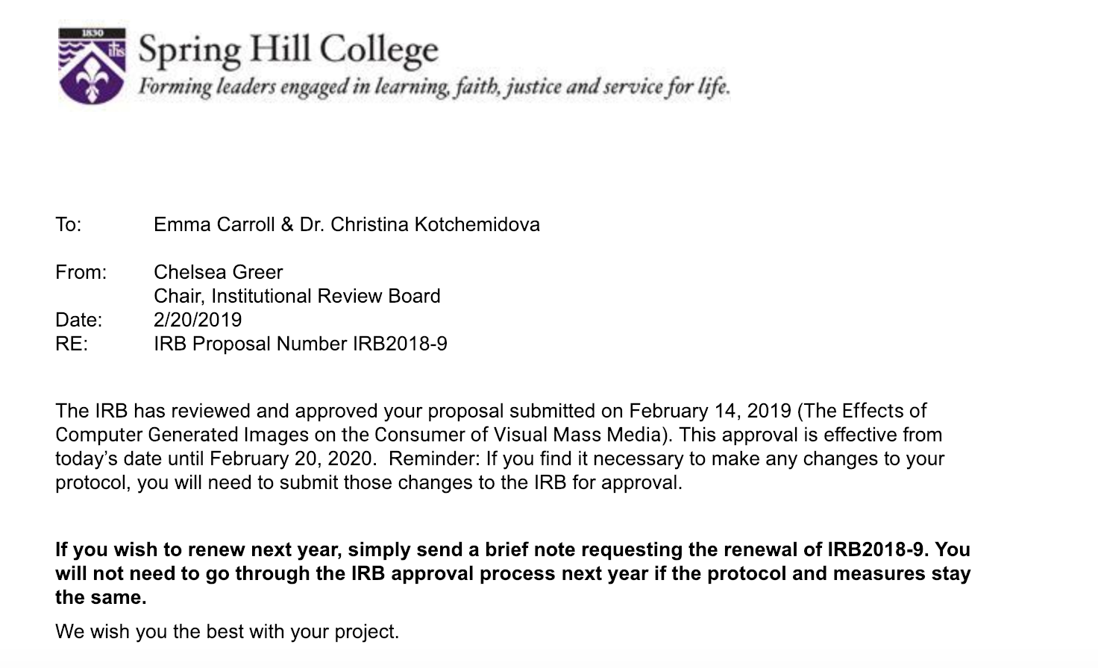

Appendix B

Webevent approval of room request

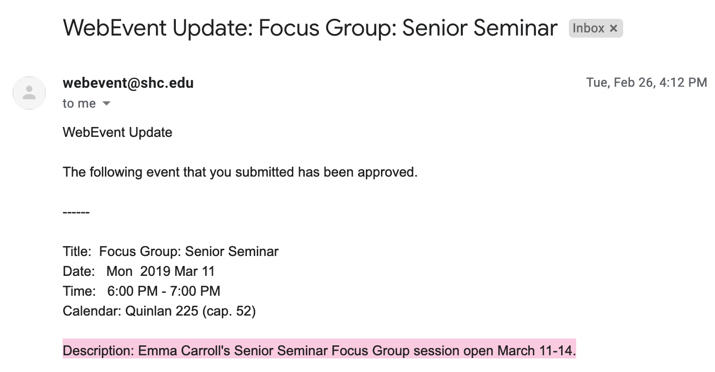

Appendix C

Flyer posted in Spring Hill class pages 2019, 2020, 2022 and emailed to a few Spring Hill College faculty members.

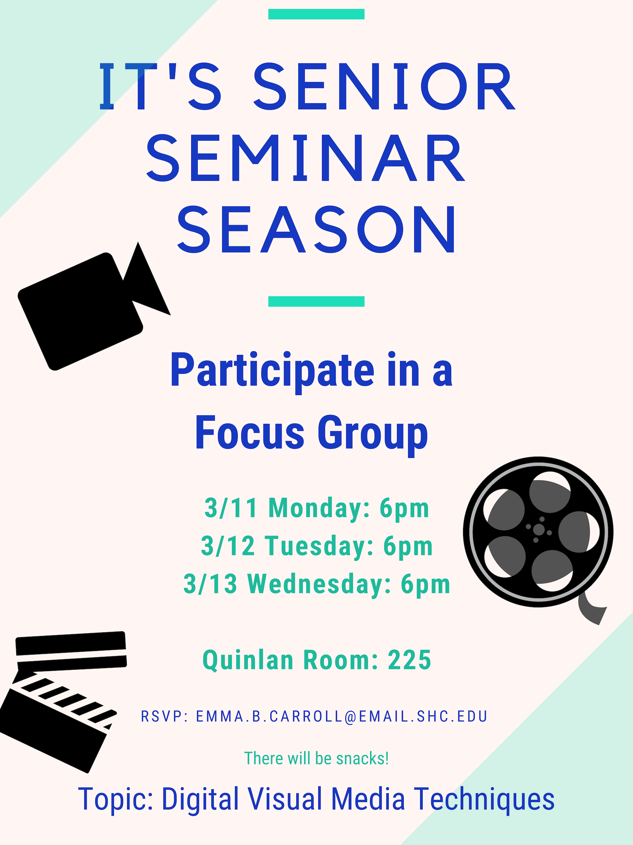
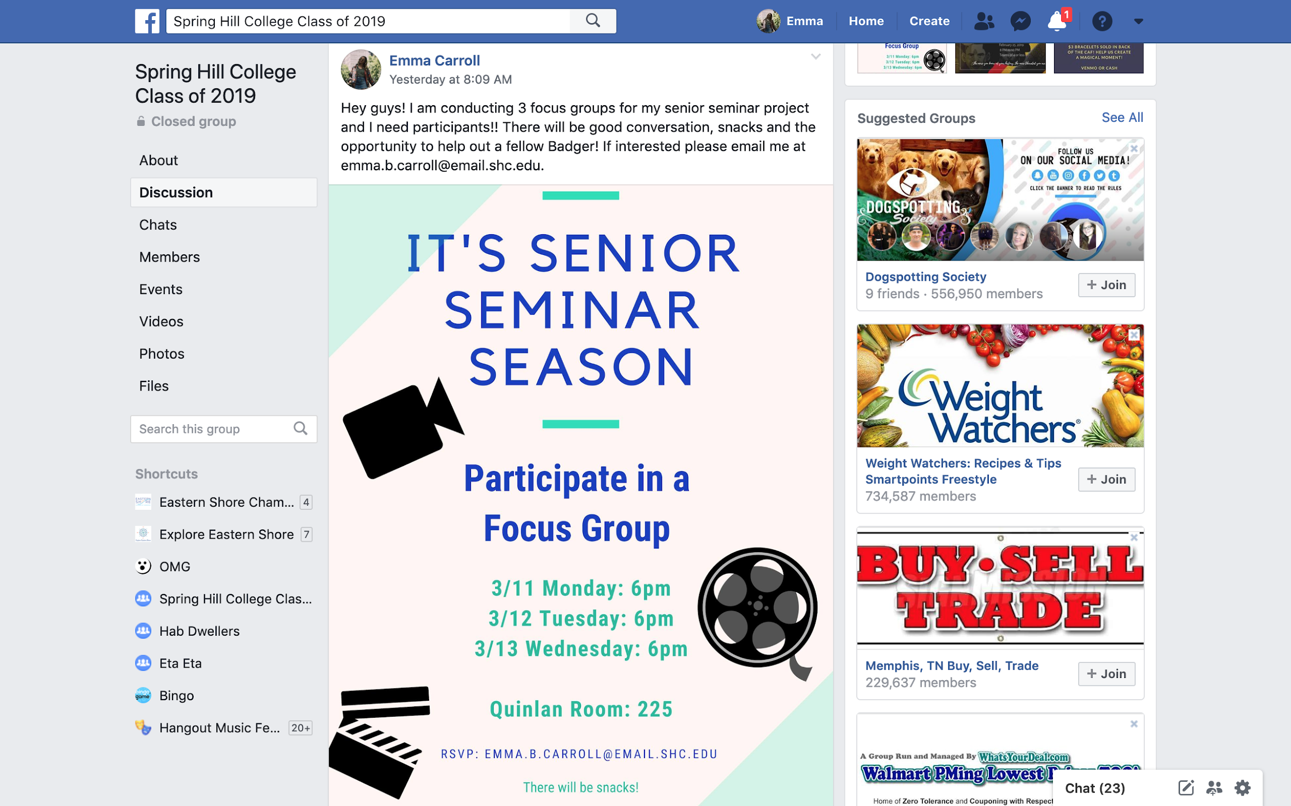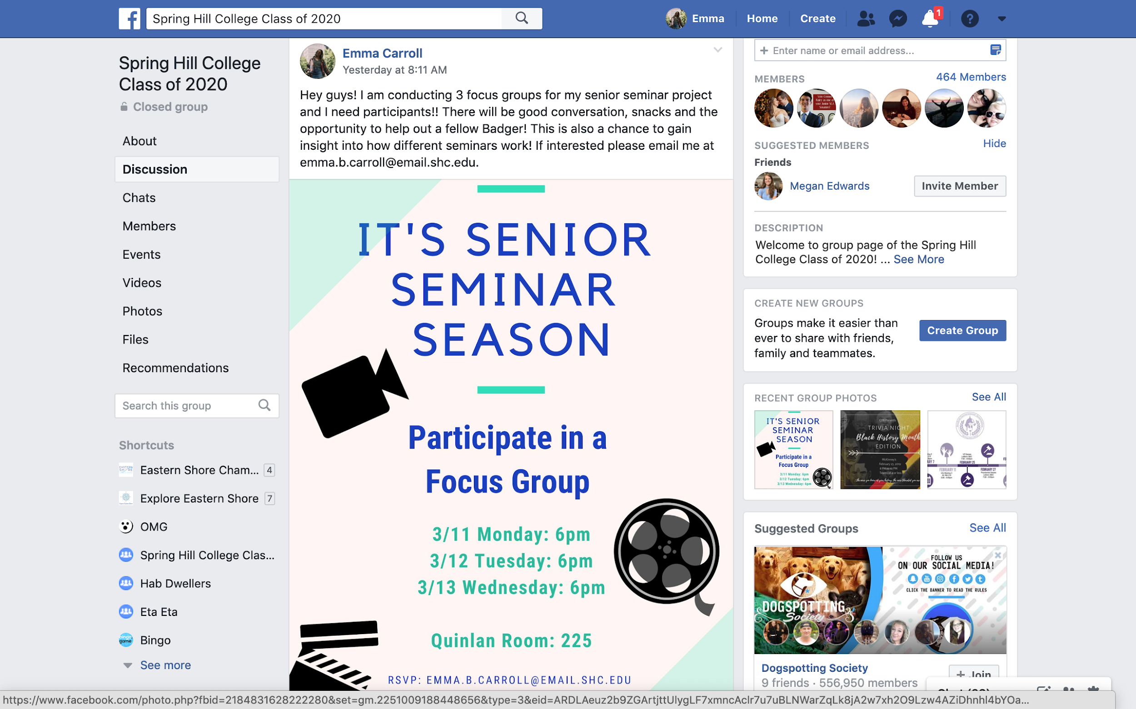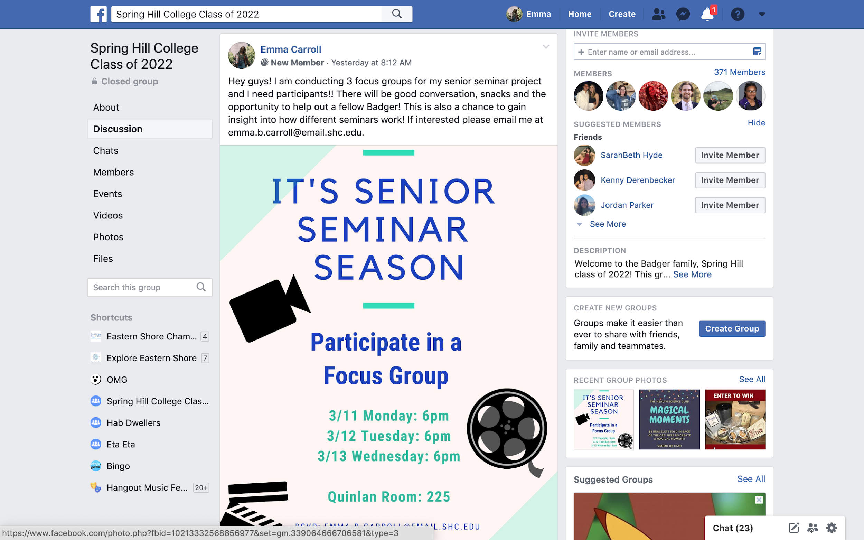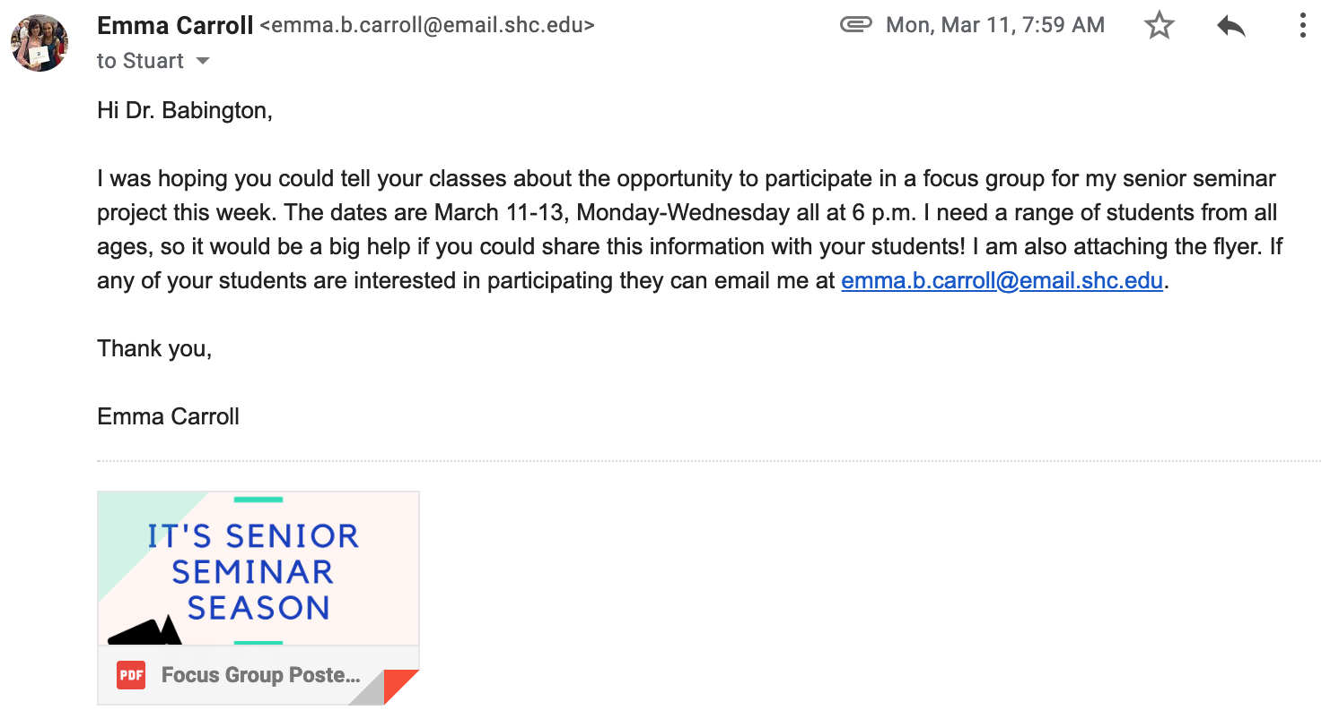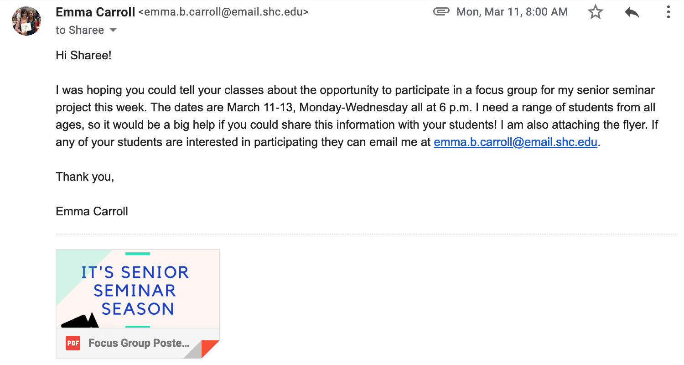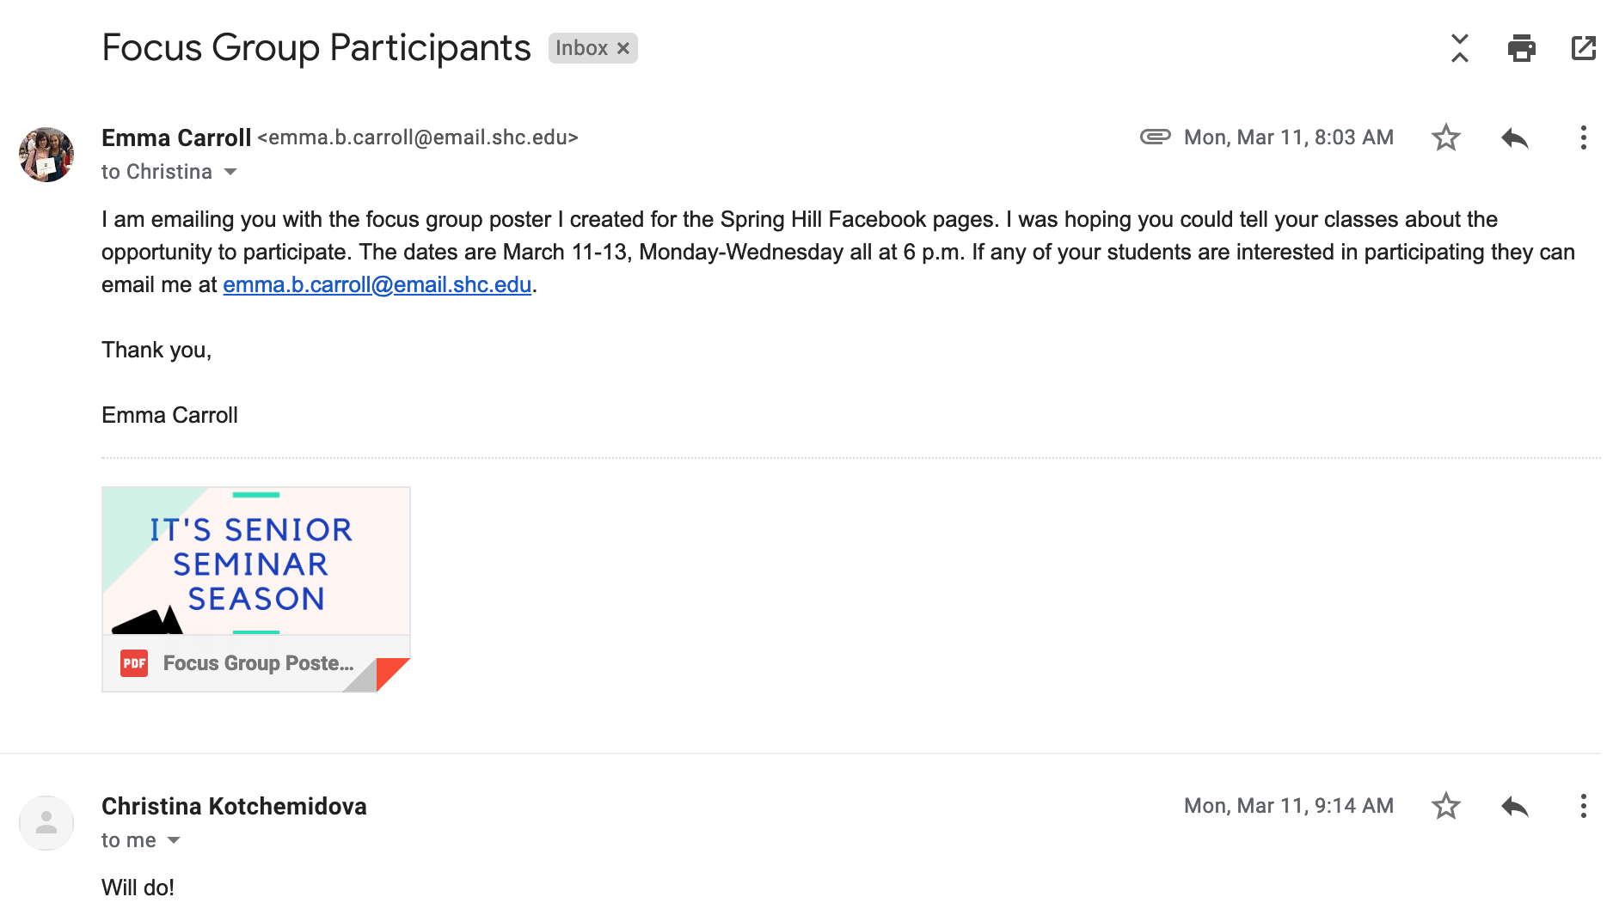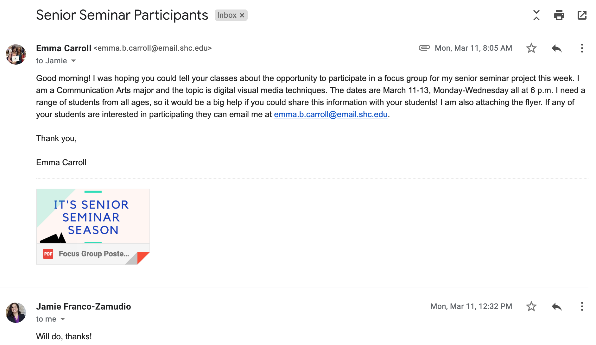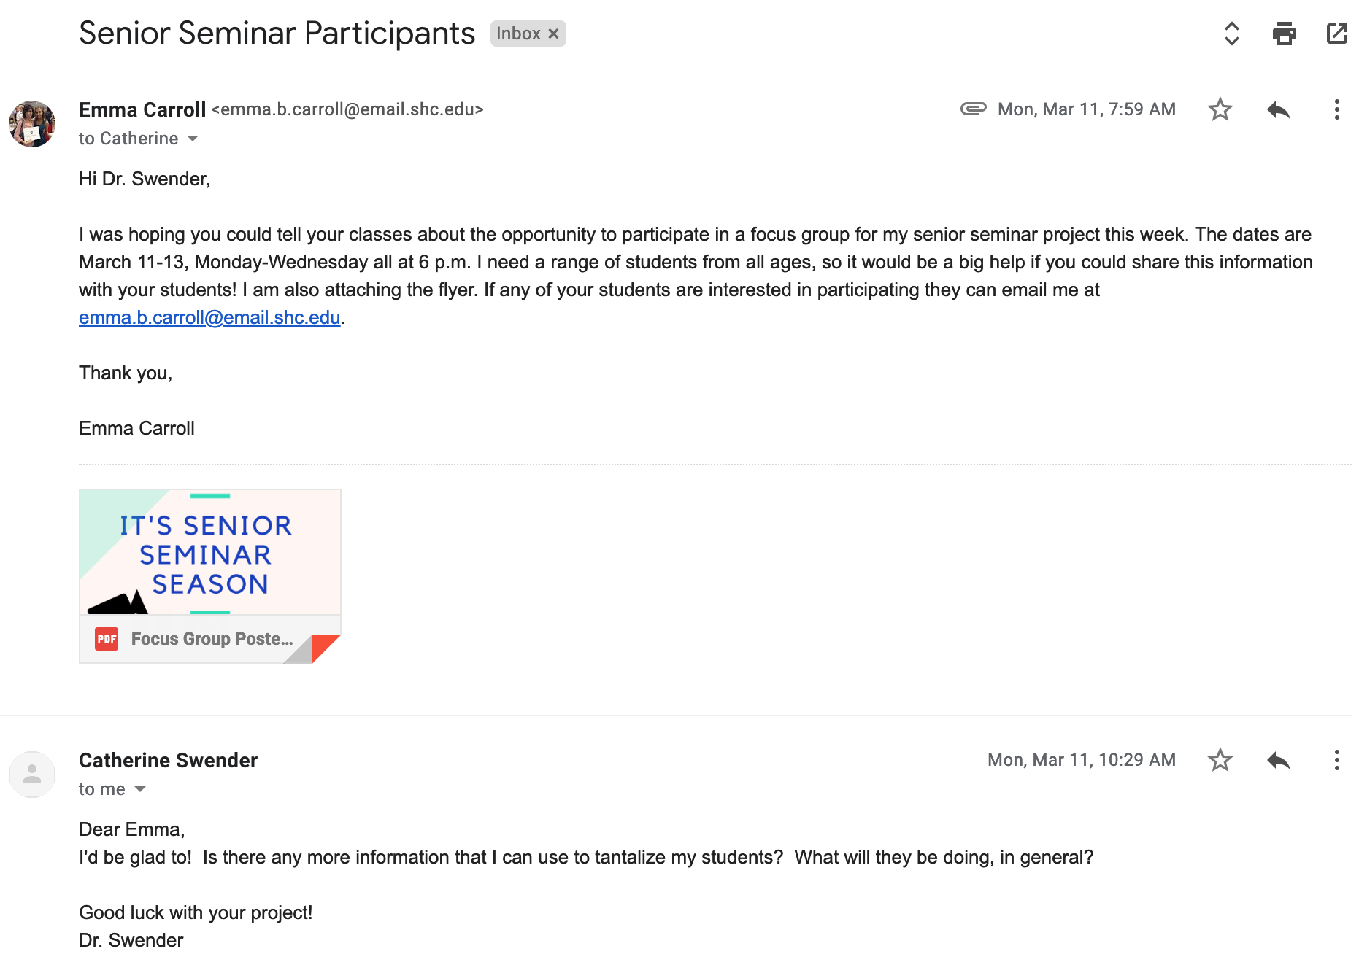
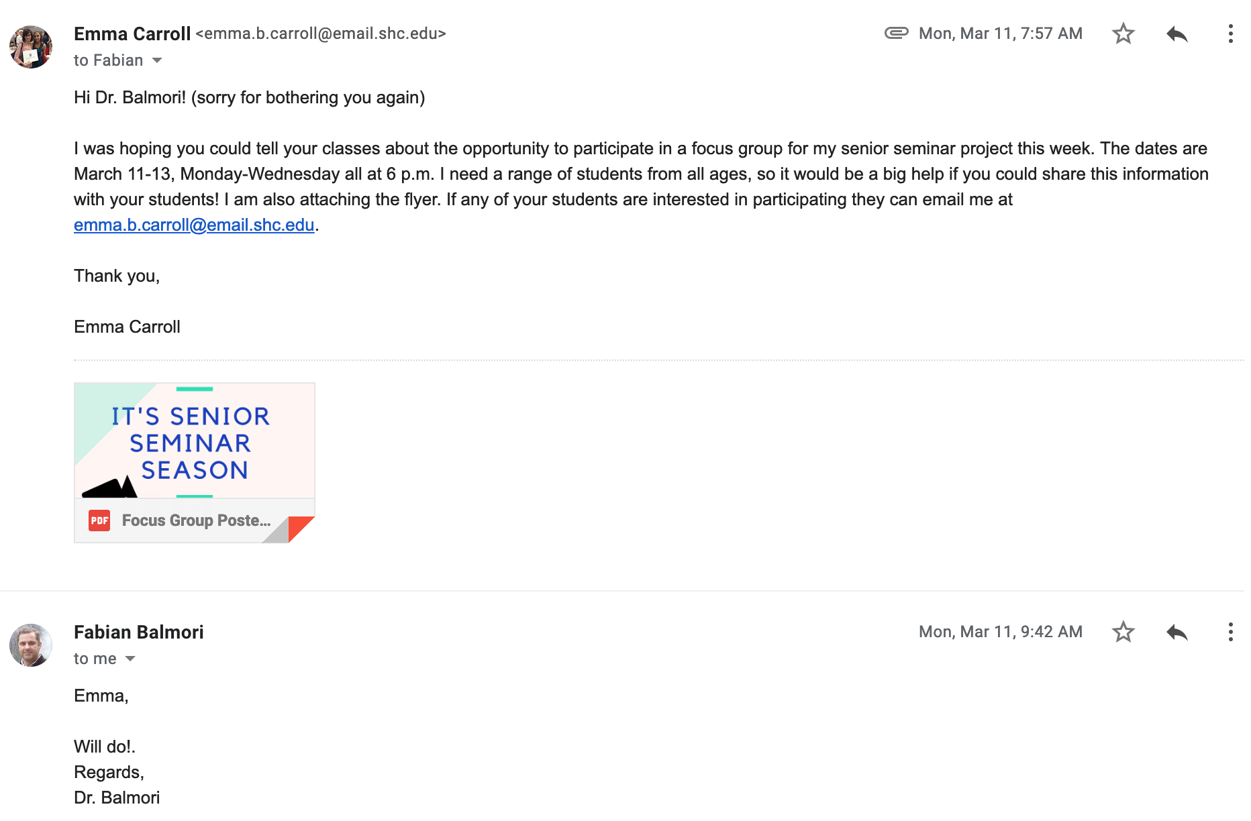

Appendix D
Sample consent form

Consent to Participate in Research
You are being invited to participate in a focus group for research purposes. In this study you will be asked to look at four still images and answer questions in conversation with the other participants.

Participant comments will be recorded for the sole purpose of maintaining an accurate record of the discussion that will be a reference for any reports derived from the discussion. Information gathered from this focus group discussion will be used in publications and presentations. All written publications and presentations will exclude any information that will make it possible to identify individual participants. Your name and your identity will not be mentioned anywhere and will not be linked to your answers.

There are minimal risks associated with the study, and you are free to leave at any time if you become uncomfortable. Possible benefits for participants include thinking deeper about film techniques and getting to hear other participants’ thoughts in an open discussion. The study will last no longer than an hour and there will be snacks provided.

You may contact Emma Carroll at emma.b.carroll@email.shc.edu any time you
have questions about the research. If you have questions about your rights
as a research subject, you may contact the Institutional Review Board Chair
at cgreer@shc.edu.

Your participation in this research is voluntary, and you will not be penalized
or lose benefits if you refuse to participate or decide to stop.
Your signature on this document means that this research study has been
explained to you, that the explanation includes the above information, and
that you agree voluntarily to participate.

Signature of Participant Signature of Witness

Print Name Print Name

Date Date

Appendix E

Sample Questions

Sample Introduction: Thank you all for coming. Before we begin everyone must sign a consent form. The consent form is to assure the anonymity of your responses in the paper. The responses will not be linked to you in any way during the paper or presentation. The focus group will also be audio recorded and transcribed immediately after. No one will have access to the recording device, but myself. At any time, you are allowed to leave if you feel any discomfort.

During the focus group please speak one at a time allowing everyone to participate and be included.

Image of dinosaur from Jurassic Park
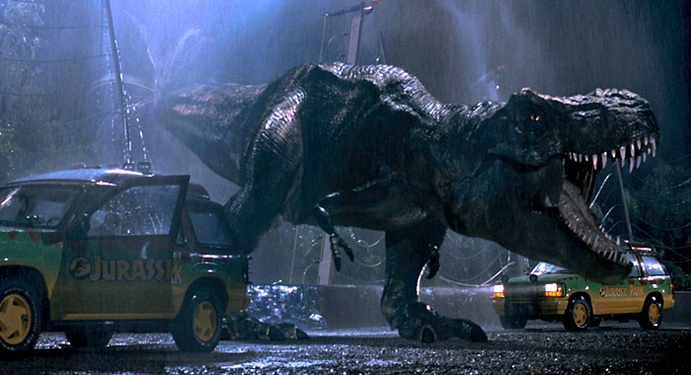
1. When you think of a dinosaur, what do you picture?
2. Is it based off a movie or an illustration found in a children’s book/science book?
- Show picture
3. How many of you have seen Jurassic Park?
4. Did you ever wonder how the images of the dinosaurs were produced?
5. Can you recognize this image as CGI?
6. Were you aware the dinosaurs were produced by CGI while watching the film?
7. When you think of the image of a dinosaur do you find yourself picturing one you saw in
Jurassic Park?
8. Would the movie have the same impact if the dinosaurs were not created as realistically
looking?
Image of Steve Rogers before (CGI) and after he became Captain America
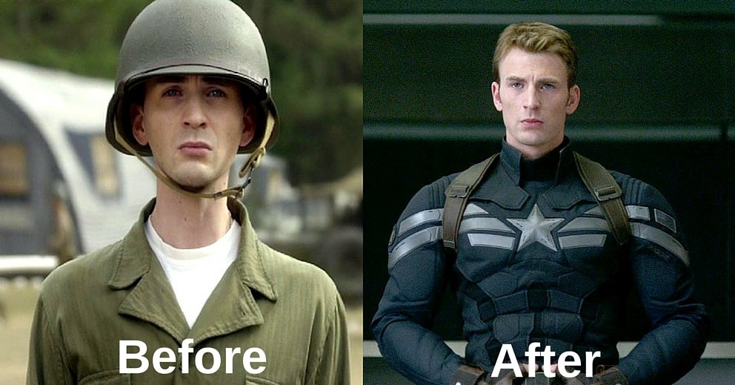
1. Have you seen Captain America?
2. Do you recall what the main character Steve Rogers looked like before he became
Captain America?
3. How do you think the actor transformed his weight for the movie?
4. Now that you know it is CGI do you think it had any effect on the way you view
superhero movies?
5. Do you think the CGI was convincing and affected the way you saw Steve Rogers’
upbringing to a Superhero?

Image from the IKEA catalog
1. Do you shop online?
2. Does seeing products online help you make a purchase decision?
3. Do you expect the product you purchase to resemble what you saw online?
4. 75% of IKEA’s catalogue products are CGI.
A. Are the products realistic?
B. Would you still shop online if you know the images of the products displayed in
the catalog are being created through CGI technology?

Image of Balmain fashion model Shudu
1. Do you recognize this model?
2. The model is completely made up of CGI – she does not exist.
A. Are you still willing to buy products showcased on a CGI model?
B. Would you prefer to see real models over CGI models?
3. What attitudes do you have towards CGI models?
4. Does this change your perception of what the qualifications should be for a model?
Concluding questions:
1. Of all the things we’ve discussed today do you think it is important for consumers to be
aware of CGI technology?
2. Is it important for consumers to be aware of CGI technology?
3. What are your attitudes towards CGI technology?
a. What drove the positive/negative reaction?
4. Do you feel CGI improves the quality of films?
5. Do you think CGI interferes with media users’ perception of reality?
6. Have you ever considered the effects CGI has on your perception of reality?
7. Do you feel comfortable with CGI in the visual media you see?
8. Are you confident in your abilities to recognize CGI
a. in films?
b. in advertising?
i. What are your thoughts about the use of CGI in advertisements?

Appendix F

Focus Group 1

When you think of a dinosaur, what do you picture?
P1: A little cartoon t-rex.
P2: T-rex.
P3: The Land Before Time like, the big ass—oh, I should probably not say—the big—that long-necked dinosaur… yeah. That was my childhood.
P4: I’d say Jurassic park. Like a t-rex.
P5: I would say Jurassic Park.
P6: Yeah, Jurassic Park.
P7: Jurassic Park.
P8: A big green dinosaur is what specifically came to mind.
P9: Jurassic World.

So basically based off movies or illustrations? You’d say?
General mumbles of agreement.

Okay. This is from Jurassic Park, correct?
General mumbles of agreement.

Who has not seen the movie? Anybody? Say yes or no.
P1: No. I mean yeah I have—I have seen it.
P2: Yes I have.
P3: No.
P4: I’ve seen parts.
P5: Yes.
P6: Yes.
P7: No.
P8: No.
P9: Yes.

So when you did see the movie—or if you haven’t seen the movie—did you ever wonder how these dinosaurs were produced? Did you think it was from a computer or from a costume?
P1: I was like four, so no.
P2: Computer.
P3: Definitely a computer.
P4: Computer.
P5: I would say computer.
P6: Yeah, a computer.
P7: Computer.
P8: I would say for the older movies not a computer, but for the newer ones yes a computer.

So when you’re looking at this picture specifically—from the first Jurassic Park—do you think that this is CGI, which stands for computer generated imagery?
Everyone at the same time: either yes or sure

A lot of you said that you were thinking of Jurassic Park on the first question. So now when you think dinosaur, do you think of this? Now that I just showed this to you?
P1: Yeah.
P2: Yep.
P3: Mhm.
P4: Yes.
P5: Yes.
P6: Yes.
P7: Yes.
P8: Yes.
P9: Yes.

(To P8) You don’t think of a green dinosaur anymore?
P8: Not at this particular moment.

Do you think that this movie would have the same impact on its viewers if the dinosaurs were big and green and not mad by a computer?
P1: Yeah.
P2: No.
P3: No.
P4: No.
P5: No.
P6: I don’t think so.
P7: No.
P8: Yes.
P9: I don’t understand the question.

So I was scared because this dinosaur looks so real. If it was made via costume or big and green do you still think it would kind of captivate the audience?
P9: No because if I think of a cartoon dinosaur, I think of Barney and I’m not scared of Barney.
P8: So no, sorry. Now that you’ve re-explained the question. So you’re saying if it was different than that, would it still have the same effect on the audience?

Mhm.
P8: No, no. Because one is a green dinosaur where it is not as scary as that ferocious-looking dinosaur from Jurassic Park.
P7: I agree.
P7: Yeah.
P6: Yeah I think the CGI adds to the scariness of it
P5: Yeah.
P4: I agree.
P3: I agree.
P8: However, you can still make a real-life dinosaur look very ferocious with good prosthetics and cosmetic make-up.

Have you seen Captain America?
P1: Yeah.
P2: No.
P3: No.
P4: No.
P5: Yes.
P6: No.
P7: Hill yeah.
P8: Yes.
P9: No.

So Captain America, Steve Rogers, at the beginning of the movie, he was portrayed as this little army boy that couldn’t really be a good soldier. They made fun of him for being a little twerp. And then he gets frozen with a lot of superpowers, and he grows up into this beautiful American soldier. How do you think he went from skinny to big? The actor. In real life.
P1: Is he didn’t an option? Like he didn’t do that?

You’ve got to explain. Explain your thoughts.
P1: Diet and workout.
P2: That could be one, or computers could just generate a new—
P1: That’s what I was going to say.
P3: Yeah, computers.
P4: I would say he was always on the buffer side but then they used computers to make him look smaller.
P5: I agree with that.
P6: Yeah, I agree.
P7: Yeah.
P8: Yeah, just visual effects.

So it was CGI transformation, Now that you know that they could just whip him up into a superhero, does that change your opinion on superheroes in general?
P1: No. I mean it’s still a fantasy. So I mean, you don’t really expect them to be real.
P2: What he said. I mean superheroes can come in all different sizes. They have short ones, small ones, I don’t know. Fast ones. Strong ones.
P3: No. I think that—what was the question again? Could you say it again? Sorry.

Now that you know that they use CGI to make him big and strong—or tiny to add to the effect of him being big and strong—does that change your opinion of superheroes?
P3: No I think a lot of what’s portrayed in superhero movies ends up being how big their heart is and, you know, what they do for their community. So I don’t think it always has to do with being big and strong.
P4: I say no just because in the end it’s fake.
P5: I would say no. It’s like he said, we all come in all shapes and sizes so it really doesn’t really matter what the appearance is.
P6: Yeah I mean I just think it doesn’t matter because the movie—you know what I mean? Like, they’re going to make him look strong.
P7: Yeah I say no because he’s also not the only one that’s portrayed as going tiny to big because there’s also ant-man who goes from big to tiny. So he’s not the only superhero that transforms like that.
P8: Yeah I’d say no as well because when people and fans think of superheroes they don’t think of a transformation. They just think of what the superhero does, and they don’t think about the certain details such as that.
P9: As someone who’s never seen a superhero movie I would actually say yes because—well it makes him less attractive if it’s not real.

So did you think that the CGI of making him tiny was convincing?
P1: Yeah.
P2: Yeah.
P3: Mhm.

It didn’t look super fake to you?
P8: No.

Did his upbringing influence how you see him? Is that what makes you think he’s so great? Because he turned into something bigger than how he was small?
P1: I mean not physically, but how he was at the beginning of the movie in his heart, I guess.
P2: I have never seen the movie.
P3: Yes.
P2: You’ve never seen the movie.
P3: I would still say yes, though. Because that’s usually what happens in superhero movies.
P8: What was the question again?

Basically, does it change your opinion since you saw him so small and then he became so big? Does that change your opinion of his upbringing to being a superhero?
P8: I’d say no because the movie and him as a person is a lot bigger than just his appearance. There’s a lot more going on than just him transforming from a puny soldier into a big superhero.
P7: Yeah I was going to say that, pretty much.

Do you shop online?
P1: Yeah.
P2: Yeah.
P3: Yes.
P4: Yes.
P5: Yes.
P6: Yes.
P7: Yes.
P8: Yes.
P9: Yeah.

When you’re buying a product do you expect it to resemble what you saw online?
P1: Yeah.
P2: Yeah.
P3: Definitely.
P4: Yes.
P5: Yes
P6: Yes.
P7: Wait do the clothes resemble what I bought?

It doesn’t have to be clothes. Anything. But if you’re buying something—
P7: Well, not from this one website I bought from—uh-uh.

But do you expect it to?
P7: I expect it, yeah.
P8: Yes.
P9: Yes.

Does everyone know what Ikea is?
P2: Yes.
P3: Yes.
P8: I’ve heard of it.

It’s a furniture store basically.
P8: Okay, gotcha.

So, a few years ago, Ikea came out to the public and admitted that 75% of their online catalog is completely computer-generated instead of creating a set and doing photoshoots. So, for example, here is a kitchen. The question is, did this product look realistic to you?
P1: Yeah.
P2: Yeah.
P3: Yes.
P4: Yes.
P6: Yes.
P7: Yes.
P8: Yes.
P9: Yes.

So if you were to buy this refrigerator you would expect it to have that exact look­­—same dimensions and everything?
Everyone simultaneously: Yes.

Would you still shop online if you knew that majority of catalogs were made through computers and not actually being modeled and taken photos of?
P1: Yeah. I mean, it’s still like a picture of what you’re buying. They didn’t just draw it up, you know what I mean?

They did exactly draw it up via computer.
P1: Completely drawn up? They didn’t photoshop none of it in?

No
P1: Oh, well. I don’t know. I guess not. Because I don’t want something that—I want a picture of it, I guess.
P2: I feel like it depends because you can’t really just take a picture of a full kitchen set. It kind of has to—they have to have different images from what they actually have in their warehouse and put it all together. So for clothing, yeah I want an actual picture but for something like that, something that is computer-generated would be fine for me.
P3: I say no. I feel like if I’m going to spend money on something that is very valuable and expensive I would want—you know—it to look real and a real picture of it I guess.
P4: I say yes because just going into Ikea and looking at the pictures versus the stuff set up in Ikea is the same thing.
P5: I’d say yes. Because, I mean, like you said sometimes they don’t have to have to have the picture or they can’t do the picture. I mean it’s still the same thing that you’re getting.
P6: Yeah I think as long as it does resemble what you’re getting then I’m fine.
P7: I say yes. And plus if you get in and it’s not what you thought—like it’s not what you expected—I mean most companies are willing to work with you on returning it or want your feedback on what the product looked like or how it is.
P8: Yeah I agree with that and—so my answer is yes—and that from personal experience I’ve never really had any problems with ordering something online, receiving it in the mail, and it not being what was depicted in the catalog online.
P9: I say yes because I only buy things online if they have free returns. So if it’s not what I wanted I can just return it. And then also—I also read the reviews before I buy something. So typically if the reviews are good, then… yeah.

So basically the fact that it wasn’t an actual set created and photographed does not change your opinion?
P8: No.
P9: Not if there’s free returns.

Does anybody recognize this model? She’s not your typical kendall Jenner, but have you ever seen her?
P8: No.
P6: No.
P7: She looks like a Barbie doll.

Her name is Shudu, and she’s completely made up of CGI. She’s not a real person. The artist built her from his imagination, and she does not exist, basically. So, would you be willing to buy, let’s say, this dress—let’s say it was a prom dress—would you buy a prom dress if you knew that the model was CGI’ed and not a real person?
P1: I mean if it was something else then I wouldn’t buy it. Just because like the way things fit. I’ve just got to know how it fits, you know what I mean? I can’t just take that leap of faith.
P2: No because same with him, if it doesn’t fit—it might fit someone who’s CGI but they’re also perfect and mannequin in the artist’s perspective, so it probably wouldn’t fit me as perfect.
P3: I agree. I say no because it’s such a—like you said—a perfect model and this tall person that has, you know, the nice long body and, you know, if someone shorter orders that then that’s not going to fit the same way. So I don’t think that’s fair to advertise that as you looking like that if you’re wearing that.
P4: I’d say no because it’s not an accurate portrayal of how it will actually look on a normal person.
P5: I would say no because it’s going to fit different people. And so it’s somebody who’s short or tall, or like bigger—

But that’s the same with tall, skinny models. You know? So what makes it different that she’s CGI?
P5: Because they could be—someone who’s tall could be maybe a little bit thicker. Or a little bit smaller. But she has the perfect body type. So it’s not going to fit person-to-person.
P2: It’s going to fit models perfectly.
P6: Yeah I mean I was going to say what you were saying. Like I don’t have a perfect body. So I see a model and that doesn’t look like me. That’s going to fit very differently. So I know it’s going to fit differently for me. So CGI and then a model that’s been photoshopped—I don’t really see a difference.
P7: Yeah, I agree. That’s what I was about to say. I say no just because they designed her to fit the typical model body, and so comparing her to a P7toria’s Secret angel, they have the same type of body. So it’s… yeah it’s a no for me.
P8: I don’t know. I don’t know. I guess I’d say no just—I don’t know. What a lot of you guys say it’s just not… its not a real… is it a real dress?

Yes. It’s a real dress. That they photoshopped onto her.
P8: No. I’d say no.
P9: I still stick with my free returns. I’ll buy it if there’s a free return.

Would you prefer to see real models over CGI models?
P1: I mean, it really doesn’t matter because they’re both—well CGI is probably more perfect, but the model—like I’m like 5’6” and I’m a guy. A model is not going to be 5’6”. A model is going to be at least like 6 foot. So I mean, it doesn’t make a difference really.
P2: It doesn’t make a difference.
P3: I would rather see like a real model. Especially because of my body type. I am super tall and lanky and I would rather see someone that’s, you know, actually tall and lanky. Or otherwise someone that’s shorter, and whatever.
P4: I’d rather see a real model.
P5: I’d rather see a real person.
P6: Yeah, I’d rather see a real person.
P7: Depending on the model. So they—I forget—maybe it’s Lane Bryant—I think that store—they use thicker women to model their clothes. So something like that, yes. As in more realistic rather than the toothpicks that they use.
P8: I’d say no because I feel like myself, and maybe most people, know what they’re looking for and know what they’re buying. So whether a dress or a suit or anything that is portrayed on a real person or a CGI person it’s not really going to sway their decision whether to buy that heavily.
P9: I mean, I’d rather see a real model, yeah.

Does this change your perceptions at all of what it takes to be a real model? Usually you’re supposed to be over 5’8” and skinny but now if they’re making CGI models is it just—do you think there’s no need for models anymore?
P1: Does it change my perspective? Well, yeah. I didn’t really have a perspective on then, but I guess that changes it.

So you don’t think there’s any need for real models anymore? They can just make them on computers?
P1: Yeah there’s a need for models, and it changes my perspective on models, I guess.
P2: No there’s no need for models if there’s CGI, pretty much.
P3: I say no because even models you can sometimes even tell that they’ve been photoshoppped. Their bodies have been like—their moles have been taken out or freckles or they’ve been even made skinnier. So it’s like, that’s not even a real model at that point. It’s basically photoshop and almost to a point where it’s CGI. So I say no.
P4: I’d say there is still a need for models because I think that’s what the CGI bases these women off of.
P5: I would say yes. I say yeah there’s a need because they can—different body types can model different stuff so instead of making CGI’s for everything they can use real people for different clothes types.

What if they make a CGI model for heavier set people?
P6: I’d say in theory no there’s not a need just because I mean when we looked at that picture we were like “oh!” I was like, “is she real or not? Like I don’t know.” Because models already are so photoshopped like you said. To the point to where it’s like, yeah it was at once a real person but now we’re seeing such an edited version that it doesn’t really matter.
P7: I say yes because one, the business side is coming out of me, and if there’s no models, they lose jobs. And then two, I like watching fashion shows so I can actually see how clothes look on people. And so without models I can’t actually get that visual of them in it.
P8: I don’t know. I couldn’t really decide what to say while everyone was going around in the circle. But, I guess my final conclusion is no just because we live in such a technology-based society that I feel like most companies and most developers could just use CGI to make a model for literally every product. Just because that’s kind of the world we live in now where technology has taken over everything almost.
P9: I say yes we do still need models because these people are fake and even if they’re photoshoping models, it’s still kind of like a real person. And you can still watch fashion shows live and on TV and stuff.

Do you think as a consumer it’s important to know when CGI is being used?
P1: No. Just because the consumer doesn’t need to know everything. You know what I mean? I mean they can if they want to and that’s their choice if they want to shop there or not.

But what if the company does not disclose that they’re using CGI models or catalogs. Do you think the consumer deserves that right to know?
P1: I mean, no. Not really.
P2: I still say no because in magazines today they don’t say that this person has been photoshopped. But you know it is, so it doesn’t really matter to me.
P3: I say yes because I’ve had experiences where I see a model that has a bathing suit on and then I’ll order that and it’s not that at all because of the way that she was developed I guess because it’s definitely been CGI or something photoshopped. So I think it’s important for aspects of shopping online and stuff like that.
P4: I say no. Because for furniture, like Ikea, you can go in the store and it’s exactly like the picture. But with clothing, I feel like you can kind of already tell if they’ve been CGI’ed or photoshopped. What’s that website that Kylie Jenner sponsors? That cheap clothing store?
P8: Oh, Athleta?
P3: No, it’s Pacsun.
P4: No, Kylie Jenner’s. I can’t think of it. But you can clearly tell that they’ve been photoshopped.
P5: I would say yes just because if you’re going to go buy something, I would rather them say this is CGI or this is a real person on the way of how it fits someone. And they can just give a description on how it fits a person.
P6: Yeah I’d say I would want to know. It just seems important to know.
P7toria: I say yes because especially when shopping online, I like to look at where it tells you how clothes fit on the person, and you can’t do that with a CGI because it’s not real—as in I will be able to tell if this is loose-fitting, if it’s tight fitting. And then if it’s movies, too, if we’re bringing movies into it, I would definitely want to know something is CGI because I’m just curious on like—this person died, but how are they still in the movie? And it’s because of CGI stuff.
P8: Do consumers have the right to know? I’d say sure, yeah. But I don’t really think it’s that important for companies to disclose that information because it’s still not going to sway their minds on whether they enjoyed that movie or whether they’re going to buy that product or not. Because consumers already have a preconceived notion of what they’re used to buying or what they want to buy. Or watch.
P9: I think it definitely it depends on the product. I think for clothes, models that are CGI-created and modeling clothes I think that’s something that you should know. But with furniture and stuff I don’t think it’s that big of a deal.

What are your attitudes towards CGI technology? Is it positive or negative? Why?
P1: I mean, there’s positives and negatives. I don’t want to steal someone’s job, like a model. But I mean, it does make movies look better I guess. I mean that’s kind of a selfish thing, I guess.
P2: I’m pretty positive with CGI. I mean, it’s useful in so many different areas, not just modeling and movies. If a few models lose their jobs they can go get a degree or something.
P3: I think it’s positive because definitely towards movies and stuff like that, it’s definitely cool to see something that’s been CGI because it looks so real. But I think in the aspect—it depends on—I think I would want to know if I was buying something that a model had been, you know, constructed that way. So I think it just depends on the circumstance.
P4: I say on a whole it’s positive with movies and the furniture because it saves times. But there’s negatives to it, like models.
P5: I would say yes and no, or positive and negative. Positive with movies and stuff, and then negative because of models. I would rather want someone who’s a person to model something.
P6: Yeah I’d say with movies it’s positive. Especially with movies with animals. I know recently the Planet of the Apes movies got a lot of praise for not using actual animals. They used CGI. So it definitely cuts down on animal cruelty and stuff in movies, which I think is definitely a positive.
P7: Yeah, I agree with all of that.
P8: I have a positive attitude I guess just because it’s great. It adds really great effects to the movies and people enjoy it. I don’t know, it doesn’t really cause any harm for movies and stuff. If companies have the resources to use CGI then I don’t see why they wouldn’t use it. They’d just be wasting their own resources.
P9: Yeah I think for—like what P6 said with Planet of the Apes and Jurassic Park when obviously you’re not going to find a real dinosaur anywhere and it’s not going to look good if a person wearing a costume is a dinosaur. So yeah CGI is a good idea but not for clothing and models and stuff.

Do you feel that CGI improves the quality of films?
P1: Oh, for sure.
P2: Yes.
P3: Yes.
P4: Yes.
P5: Yes
P6: Yes.
P7: Yes.
P8: Yup.
P9: Yes.

So you would not be bothered by CGI in films? Are you expecting it to make the movie better?
P1: I mean, I guess yeah.
P2: I mean, so many movies have CGI that we don’t even know. So it doesn’t really matter. It’s there.
P3: I think it’s a positive thing.
P4: Yes.
P5: Yeah.
P6: Yeah I think it adds to the movie.
P7: Yeah especially—well I mean, rom com I don’t really see too much of a need for something like that, but Captain America and those movies definitely yes.
P8: Yes.
P9: Yes, but I think that there can be a point when it’s too much. Like when they start using CGI in films for human characters or a tree or something that they don’t have to use CGI for I think it will get to be too much.

Do you think that CGI interferes with the consumer’s perception of reality?
P1: Yeah. Well I mean, if, like you said, they use CGI for pictures of models and stuff like that, then why would you believe them when they say it’s not CGI? I mean, it just loses trust.
P2: Yes. Because you can create the perfect human being on CGI essentially. Well I mean, there’s CGI in every film. From the littlest aspect to the biggest dinosaurs. So—I don’t really—no. I don’t think it really affects people in films that much.
P3: I don’t think it affects people that much but I think it’s almost in some aspects positive, like in the new movie Bohemian Rhapsody. They did CGI for all those people that were in the crowd so that it would depict what it would really look like in actual concert. So I think that was a positive aspect in the way that they used it because it allowed the consumer to really feel and understand what was going on during the concert, if that makes sense. So I think it has a positive effect.
So you do believe it affects your perception of reality?
P3: Yes.
P4: I say to some extent, like with models, but not with dinosaurs. It doesn’t change your perspective on reality with dinosaurs because they don’t exist anymore.
P9: But they look pretty real.
P4: But who actually thinks they’re real?
P3: Little kids.
P5: I would say no with movies because people should be able to know what’s real and what’s not, but with models and stuff, I would say yes.
P6: I agree completely
P7: No because I mean I’m a big marvel person so I know this isn’t real and so it doesn’t affect me.
P8: Yeah I’d also say no that I do not think it affects a consumer’s perception of reality because people know what’s real from fake, even when they’re watching something as simple as Barney to—I don’t know—Game of Thrones or something. Or, you know, Planet of the Apes or something.
P9: I think yes when it comes to the models because I mean you see models made with CGI and—like that’s not real but you don’t necessarily know when—whatever. But I also think yes with movies—not necessarily for Harry Potter and Jurassic World or anything like that—but kind of like what P3 said with Bohemian Rhapsody. Once it gets to a point where you start editing people or things that don’t need to be edited then I think yes, yes it does.

Are you comfortable with the CGI that you see in visual media?
P1: Yeah, I’m comfortable with it.
P2: I’m comfortable.
P3: I’m comfortable.
P4: I’m comfortable with it.
P5: I’m comfortable.
P6: Yeah, I’m comfortable.
P7: I’m comfortable because I feel like if we didn’t have it some movies would be very boring.
P8: Yeah it’s more than some movies.
P7: A lot.
P9: Kind of. I feel like we’re in an age where everything is so generally edited, and even though yeah we do—it is increasing the quality of like, Jurassic World movies. But I mean, the first Jurassic Park came out in what the 90s? That wasn’t very CGI’ed. If you look at the Harry Potter movies those obviously have a little bit of CGI but not nearly as much—and I’m talking about the old ones, when Harry was like eleven. If you look at the newer ones you can tell that there’s a lot in them. So I don’t know I just don’t think there’s as much of a need for it as it’s used.

Are you confident in your ability to recognize CGI in movies?
P1: No.
P2: Sometimes.
P3: Sometimes.
P4: Sometimes.
P5: Yeah, it depends.
P6: For the most part.
P7: Yes, I mean if there’s an alien coming out of the sky I know that is not real.
P8: I’d actually say—from my personal experience—I’d say no because today I was watching a how-to for Game of Thrones—I love Game of Thrones—and there’s this one scene where there’s these masses of zombie things running through this wall. Literally, I’m talking like hundreds or thousands of them. And they said they only used like 40 actors, but I don’t know it really looked like they used hundreds of people. So I really couldn’t tell in that kind of sense.
P9: I say yeah just because I watch a lot of older movies, and sometimes when I watch newer movies it just looks so fake. Just faker than real world I guess.

What about CGI city-scapes? Like Washington, D.C. if that was CGI’ed and they didn’t actually film in Washington, D.C. do you think you’d be able to tell if it’s real or fake?
P1: No.
P2: No.
P3: I think if I’ve been there. I know that sounds weird.
P4: No.
P5: No.
P6: No.
P7: No.
P8: No unless it’s really poor CGI and you can tell it’s animated.

Does it bother you that things such as history and buildings and places can be CGI’ed without you knowing?
P1: Not really.
P2: No.
P3: I think if it’s in the advertising aspect—like it’s trying to get you to go to D.C. or something like that—I think that’s kind of like—I don’t know how to say it—a misperception of reality I guess. And that’s kind of like, not a letdown but just—I don’t know how to say it—fake I guess. It’s messed up.
P4: I’d say no.
P5: No.
P6: No.
P7: No
P8: No you can always go research or google what something actually looks like.
P9: Yeah I feel like we’ve gotten to a point where enough people have been to any location that you can’t digitally edit it to the point where it looks that fake. What’s the question?

Does it bother you?
P9: No because I feel like they can’t edit it enough to where it would look so fake that you know its edited.

So were you confident to recognize CGI in advertisements such as that Ikea picture?
P1: No.
P2: No.
P3: No.
P4: No.
P5: No.
P6: No.
P7: Not at all.
P8: No.
P9: No.

What are your thoughts about the use of CGI in advertisements versus movies?
P1: I mean, I don’t like it in advertisements. Well, in certain things. I really couldn’t care if it was used in advertisements, but I could see how someone would buy a bathing suit and want to see a model. Like a real person. But, I mean, that’s not personally an issue with me. But with movies and stuff, that’s fine.
P2: Movies, perfectly fine and for advertising … I don’t care if the person is CGI’ed. It’s really the product that you’re buying. You’re not buying the person’s figure.

What if the product is CGI’ed as well?
P2: I mean they can’t alter the CGI to be so far away from what reality is. That would just be fraud. So it has to have a certain actual representation of what the real product is. I feel like you can get a very clear image from the CGI of what it’s actually going to be.
P3: I think in movies it’s positive, but—and I’m just going to say this again—in stuff like if you’re buying clothes online or something and it’s a person that’s CGI, most of the time it’s not going to look the same on you and I don’t think that’s okay.
P4: I think it’s positive in movies and then it can be positive in advertisement. But not always.
P5: In movies it’s fine. In advertisement it kind of depends. With clothes I would rather it be on a person so I can see how it fits.
P6: Yeah I’d say with movies it’s positive. Advertising, probably negative for the most part.
P7: Yeah. Movies can be positive unless it’s really poor CGI. And then advertising, like I said earlier—I mean I’ve bought a product before because of what it said online. But it was literally nothing like it said. And that’s because I didn’t—like there was no pictures or anything of how it looked on a person. And so I feel like if I would’ve been able to see what it actually looked like besides it just being a CGI picture, then I would’ve had a better idea.
P8: I think CGI is actually fine for both. Movies just because it adds to the affect and people don’t seem to really think CGI is a problem with movies. And in advertising—again, like I kind of said earlier—I think most consumers just know what they want to buy. And if you are really unsure whether something is what is truly depicted in the picture, then you might as well just go to the store and check it out and try it on for yourself instead of taking a risk and buying it online and it not being what you expected because of something that was produced with CGI.
P9: I think in movies it’s mostly okay. And then I think for advertising—honestly the biggest problem I would have with advertising would be with models because you can go on some websites and they will tell you the model has these measurements and they are wearing this size. And so that a lot of times will help me figure out what size I should buy, but if the model is CGI’ed they can’t really do that. And even if they edit the model, they still can’t really do anything like that.

Focus Group 2

When you think of a dinosaur, what do you picture?
P1. The long-necked stegosaurus is the first one that comes to mind. Like in Jurassic Park when it’s eating the trees.
P2. I picture the long-neck one, but in a cartoon form. And it’s green with a bald head.
P3. I picture a tyrannosaurus rex, kind of scary, big teeth, large, towering over everyone.
P4. I also picture a tyrannosaurus rex, but, like Dylan, mine was animated.
P5. I think of the velociraptors from Jurassic World.
P6. I thought about the t-rex that had the spine thing on its back—the little fin thingy.
P7. I think of a t-rex, but out of proportion. You know, huge head, tiny arms, very very small body.
P8. I also think of the long-necked stegosaurus, and they seem, you know, friendly and, you know, vegan.
P9. I definitely think of a t-rex. Same kind of with Ben like the tiny arms that are just mauling like all the other dinosaurs.
P10. I think of a stegosaurus from Land Before Time.
P11. I, too, think of a Brontosaurus—the long-necked one.
P12. I think of Land Before Time, but I also think about the different types because they have the meteors and the plant ones, and so it’s just different kinds.
P13. I think of the green, animated, bald dinosaur.

How many of you have seen Jurassic Park?
*everyone raises their hand except for P4*

This is the t-rex from Jurassic Park. Have you ever wondered how these images were produced for the film?
P1. Yeah, all the time.
P2. Yes.
P3. I’ve also wondered how these images are produced.
P4. I have not been so curious. I just was like, “oh! CGI dinosaurs,” and that was the extent of that.
P5. I don’t really think about it.
P6. I’m a bit curious.
P7. Yeah, I don’t really think about how the stuff I’m watching is made as much as I care about enjoying what I’m watching.
P8. I was impressed by it, but I never actually wondered how it’s made.
P9. Yeah, I’ve wondered about it before.
P10. Yeah, I mean, I was a little curious.
P11. I, too, was curious.
P12. I’m curious because I think it was ahead of its time. At the time, there was nothing like that. So, it’s pretty cool.
P13. It doesn’t really cross my mind, but I’m curious.

When you looked at that image, could you tell that it was CGI? Or did you think it was costume?
P1. I thought it was all constructed, like it was a physical thing.
P2. I thought it was CGI.
P3. Yeah, I thought it was CGI as well.
P4. From the snippets of the movie I’ve seen, I thought it was CGI.
P5. Me too.
P6. I would assume its CGI.
P7. CGI as well.
P8. I believe it could be a mixture of both CGI and costume.
P9. Yeah, I’m just going to repeat what everybody else said. CGI.
P10. I have no idea. I think construct, maybe?
P11. I think it could be a mixture of both.
P12. I thought it was CGI, but not at the time that it came out.
P13. At the time it came out, I think it was a robot. Like, with costumes.

When you think of a dinosaur, do you find yourself picturing one that resembles the one from Jurassic Park?

P1. I guess when I do happen upon thinking about dinosaurs, I guess thinking of the more animated ones. Not necessarily the super realistic ones seen in Jurassic Park.
P2. Yeah, I guess it depends how long I think about it. The initial one was animated, but if I’m thinking about dinosaurs I will also picture the ones like that.
P3. Yeah, that image is similar to the image in my brain that I think of when I think of a dinosaur.
P4. My image is more realistic than a cartoon, but not like that. It’s kind of like the Meet the Robinson’s t-rex. That’s what I picture.
P5. I picture it like the picture.
P6. I picture Jurassic Park, although I know that that’s highly unlikely what they actually look like.
P7. Yeah, I imagine dinosaurs like Jurassic Park, but I don’t picture them as something that would just like maul anything it sees. More like a dog figure, like a pet or so.
P8. I usually imagine them as the friendly animated versions.
P9. Yeah, I usually think of the terrifying versions from Jurassic Park.
P10. I agree with what [P2] said about, like, that’s not the first thing that comes to mind, but if it’s on the topic of dinosaurs it will come up.
P11. I concur with [P10].
P12. I think of the realistic kind, like the ones you see in Jurassic Park.
P13. If I’m thinking of a t-rex, I think of that one.

Would you think the movie would have the same effect if the dinosaur was not as realistic? Let’s say it was more green and animated?
P1. Definitely not, especially considering that was its big break-through with how realistic the dinosaurs look.
P2. No I definitely don’t think it would have the same effect. I think about the original Ghost-Busters. It would be a similar situation where like, good movie but not super scary.
P3. I agree with [P1] and I also think it was meant to kind of strike fear into the viewers. Like you think that dinosaurs are really scary.
P4. Yeah kind of what everyone else has said, it’s supposed to invoke some sort of fear, and if it doesn’t look scary then it’s not really going to do that.
P5. I agree.
P6. It would definitely give off a different point of view.
P7. I agree.
P8. I believe it would lose its sense of reality and be less scary.
P9. I also agree.
P10. I agree.
P11. Yeah, I would agree just because it would seem more cheap if they were faker dinosaurs.
P12. I agree with everyone else.
P13. It wouldn’t be scary if it didn’t look real.

Moving on to our second image. So, who has seen Captain America?
*everyone except for P1 and P13 raises their hands*

How do you think that the actor transformed his weight for the movie?
P1. I would assume just change of diet to high protein and a really specific workout regimen, but I don’t really know.
P2. Yeah, he probably did some type of really intense workout-diet regimen.
P3. I’d say probably working out over an extended period of time as well as a diet change.
P4. I agree with that, but I also think potentially—if you can CGI a dinosaur, I feel like you can CGI some of him to look more muscular or less muscular.
P5. I think it was a mix of working out overtime and computer stuff.
P6. Yeah I think it was some kind of extreme regime, and also probably photoshop.
P7. Yeah the regime and I feel like it’s just not the same person.
P8. I’m sure Chris Evans worked out before for the goal but then used CGI to give him the small-framed body.
P9. Yeah, definitely just working out and dieting and changing his schedule.
P10. Yeah, I think that, as everyone else has said, working out and dieting.
P11. Yeah I think he did work out, but they definitely did something computer wise.
P12. I think they did something computer wise, but I also do think he worked out because when I think of other superheroes, some don’t have to do as much like how he had to.
P13. I think it was workout and I also think costume choices and that kind of stuff.

Now that you know that his little body was CGI, do you think it has any effect on the way you view superhero movies?
P1. No because, I guess—I mean, I’m not really big into them but maybe if you are, you kind of—they’re based off of comics right?—so if they’re kind of made to look like what they’re originally portrayed as anyway. So, it being CGI, whether you know it or not, doesn’t really effect it I think.
P2. Yeah. I think it gives me more of an appreciation for superhero movies and the stuff that they do to stay authentic to the story.
P3. Yeah. I think when you think of superheroes you think of big and strong, and the fact that he was already big and strong kind of exudes that image of what you think of when you think of a superhero.
P4. It doesn’t change my opinion on any of the movies. However, how impressed I was that he could go from skinny to buff is now gone, but that doesn’t really matter because the movie was still good.
P5. It doesn’t really change my opinion because I know superheroes aren’t real.
P6. It doesn’t really change my opinion, but I do find it strange that they use CGI to move backwards instead.
P7. Yeah, it doesn’t really change my opinion either.
P8. It does not change my opinion.
P9. Yeah it doesn’t really change my opinion. I mean, it’s just a movie so, I mean, it’s kind of expected.
P10. Yeah.
P11. Same.
P12. Same.
P13. Same.

Do you think the CGI was convincing and affected the way you saw Steve Rogers’s upbringing into being a superhero?
P1. Yeah, I was completely fooled just now, so yeah.
P2. Yeah I think it gets the job done.
P3. I agree.
P4. I agree.
P5. I agree.
P6. I agree.
P7. Yeah, I’d say that.
P8. I agree.
P9. I also agree.
P10. I agree.
P11. I concur.
P12. I agree.
P13. I agree.

Does everyone shop online? We all shop online? Do you expect the product you purchase to resemble the photo you saw online?
P1. It’s a bit more dodgy with the cheaper sites, but with more reputable brands, yeah.
P2. Yeah, it depends on the product and the site that I’m getting it from.
P3. Yeah, the more I shop online the more I don’t expect to look exactly like what I’m ordering online.
P4. I agree with [P2] it depends on where you’re ordering from and the quality of what you’re buying.
P5. I expect it look identical to what I see online, but I’m not shocked when it doesn’t from cheaper websites.
P6. Like the picture? I go look in the comments or at the actual dimensions of it so that I know if it looks like the picture or not.
P7. Yeah, I expect certain quality from certain products, like Apple or Polo or those higher-end brands. But if you get something from Wish, I think that’s like—I’m probably going to get garbage.
P8. Most of the time I actually do not expect it to look like the image.
P9. Yeah I expect it to look kind of similar, but not really exactly right. It’s a little different like if you get fast food it kind of doesn’t look exactly like it at all.
P10. I think that it just depends on the website.
P11. Yeah I kind of do expect it to look like what I’m buying, but it’s always a known false hope.
P12. I expect it to look like what I’m buying, but it only depends on the website that I’m buying from.
P13. I expect it to look like it with higher end brands, but with lower end, I like to read the reviews to figure it out.

Does everyone know what Ikea is? They revealed a few years ago that their catalog online is 70% CGI’ed. So, not all of their products were built and shot for the website. It was made entirely on a computer. For example, this is one of their kitchens. This image was created by CGI. It wasn’t actually built. But, everything you see can be bought. You know, if you want that fridge or if you want that stool. It can be bought. But they didn’t actually build this set. Also, Ikea disclosed that they’re not the only website that does this, they’re just one of the only companies that have disclosed this information to the public. Do you think that this product is realistic? If you were to buy something from this picture do you expect it to be realistic?
P1. Yes, just because I feel like people who were making the CGI were using a physical model anyways, and I don’t think it’s necessarily that difficult to replicate. So, I would expect it look pretty similar.
P2. Yeah, I think so as well. I also think it makes it more enticing for the consumer to buy, especially since you can make it look very similar to those CGI images.
P3. If I were to purchase something, I would expect similarities, but I wouldn’t expect exact. I would expect it to be close enough that I wouldn’t be upset.
P4. I think I would expect it to look like the picture because Ikea is a pretty good company.
P5. This doesn’t really surprise me because most beer companies these days will use soap or something in their glasses and then pour the beer in to give it more foam. So, we’re always lied to about that kind of stuff.
P6. I think a fridge in that picture is going to be the same as a fridge that I get at the store. So I expect there not to be a whole lot of differences.
P7. I mean if it’s based off a real-life model, I would expect it look like that.
P8. Yeah, I agree. I would expect it to look pretty similar.
P9. I agree. It should look how the picture does.
P10. I kind of trust Ikea.
P11. I agree with everyone else.
P12. I think the actual items will look the same, but out of the context of the kitchen, even if that’s real, they always look kind of different.

Now that you know that more than just Ikea catalogs are generated with computer technology, are you still willing to shop online?
P1. Yes. Just kind of like the “buyer beware” kind of thing.
P2. *gone from the room*
P3. I agree with [P1].
P4. I have always been able to kind of tell. Especially if you’re deciding between two different colors of a product, you can tell that it’s been—like you can tell that it’s the same picture that’s been modified to have a different color.
P5. I agree with [P1] and [P2].
P6. I still trust it. Just check reviews first.
P7. Yeah, it definitely makes me more aware of when I’m purchasing products online.
P8. I would agree.
P9. Yeah, I agree but just because it’s more convenient for me than having to go to an actual store.
P10. I agree with [P1].
P11. I concur.
P12. I agree.
P13. I agree. I’ll check the reviews.

Onto our last image. This is an Instagram model. Have you seen her photos before? This model was completely designed by CGI, but she does real fashion campaigns. She was created for Balmain, which is a really big company, and she also has modeled Tiffany and Company jewelry. She is now actually one of Rihanna’s models for the Fenty Beauty make up line, if you’re a familiar. She’s not based off of a real person. It’s not like they looked at someone and then put her on a computer screen. This was made completely by the artist’s mind, artist’s integrity. If she was showcasing something that you wanted to buy—let’s say she was a boy and she was modeling shoes or whatever—would you still buy this product? If you knew she was CGI or he was CGI?
P1. Possibly. I’d probably want to see maybe more pictures of the shoes stand-alone, just maybe for the more realistic effect. But I probably would.
P2. *gone from the room*
P3. I don’t think it would make much of a difference. I’m not going to buy something based off of the person modeling it. I’m going to buy it based off the product and if it’s something I want or need.
P4. For clothes specifically, you can see something on the rack and it be cute and then when you see it on it’s not as cute. So I would be skeptical because I know it’s not on someone’s actual body, so I don’t know if that’s actually how it falls on someone. So I’d be skeptical of clothes, but with something like jewelry or something that doesn’t really need a shape for you to see it, then I would be fine.
P5. I agree with what [P2] said, and I would definitely have to check the reviews.
P6. I would check the reviews as well.
P7. Yeah, I agree with [P2].
P8. I also agree.
P9. Yeah, I agree. If the product is still nice and everything I’m still going to buy it.
P10. I agree.
P11. I think I probably would be less prone to buy something because I already feel like I’m being deceived. It’s not actually on someone, and I’d be wondering why.
P12. I don’t think it really changes anything.
P13. If it were clothes I’d want to see it on a real model.

Would you prefer to see real models over CGI models?
P1. Kind of like what everyone’s been saying before, at least with clothing or things that need shape, like what [P4] was saying, then yes. But otherwise, not really.
P2. I don’t think I would be swayed either way.
P3. Yeah it wouldn’t matter to me.
P4. It really just depends on the product, like I said in my last answer.
P5. I feel like it really doesn’t matter because I feel like the CGI models are designed to have your typical model body anyway.
P6. I don’t think it really matters. Even if it was a real person, they’d photoshop it anyways.
P7. Yeah, I’m just buying the clothes so I don’t think it really matters.
P8. I mean, I would prefer to see it on a real model over CGI.
P9. Yeah, I don’t think it really matters either way.
P10. It doesn’t really matter to me.
P11. I’d prefer a real model.
P12. I don’t think it really matters because at the end of the day, everyone’s different. So what might look good on that person when you try it, it probably won’t look good on you.
P13. I’d prefer a real model because then it’s like, the clothes aren’t real.

Of all the things that we have discussed, what would you say are the most important issues or realizations about CGI technology in our world?
P1. Just kind of like, not everything is what it seems, and that’s important to keep in mind. Especially when you are shopping around, and maybe to not expect perfection. But maybe you can also just appreciate movies and things like that some more because that stuff is really intense and intricate.
P2. Yeah, I think people should just approach things with an heir of skepticism, especially if it’s a news headline with a picture or something that just—if it looks ridiculous, it might be CGI. Just understand that.
P3. Yeah, I think it can be very deceiving. I also feel like, especially if you’re advertising something, you’re going to want to make it look as good as you possibly can. But like what [P1] and [P2] said, I think you just need to be aware of what you’re watching or what you’re buying and just realize that it’s not going to be that perfection that it’s portrayed as.
P4. So like specifically for models, even real models wearing things aren’t really realistic to the consumer base anyways. So keeping that in mind and knowing that some models might be CGI’ed, even that’s unrealistic as well. But like I just said, real models are pretty unrealistic because nine times out of ten the woman buying the clothes doesn’t look like the woman wearing the clothes online, so it doesn’t really change a lot anyways.
P5. I agree with all of them.
P6. Yeah, I don’t think it really matters because no matter what, if the company wants to sell it, they’ll photoshop whatever they need to make it sell anyways.
P7. Yeah, I think it’s important to find out what’s real and what’s fake and what you’re buying.
P8. I agree. It doesn’t really matter because both different types could be edited and still have the same results.
P9. Yeah, just be aware that not everything is like it seems.
P10. I agree, just keep your awareness.
P11. I concur.
P12. Looks can be deceiving.
P13. I think it’s cool with movies, but with the models, I don’t like it. I wouldn’t—no.

Do you think as a consumer it’s important to be aware of the CGI technology?
P1. I think so. Especially if maybe you’re seeing something and you have your own insecurities, it might be kind of comforting to know that it’s not necessarily all real. But of course just always “buyer beware” kind of thing.
P2. Yeah. I think it is important to be aware of CGI.
P3. I think so as well just for the same reason as my last answer. Nothing’s going to be as perfect as it’s portrayed.
P4. I agree with everyone.
P5. I agree with everyone.
P6. Yeah I’d say be aware, but I don’t think it actually makes much of a difference.
P7. Yeah, for movies I don’t think it’s much of a problem just because CGI is used to enhance the experience, but as far as products go, that can be important because you don’t want to be swindled or buy a product that’s not what it really looks like.
P8. I believe that the consumer should be informed if it’s CGI.
P9. Yeah, I agree.
P10. I agree with what [P7] said.
P11. Yeah. I’d rather be aware if a product is CGI or not, but for the sake of movies I think it’s just for benefit of the buyer.
P12. I think it’s important to be aware.
P13. I think if for products they’re going to do CGI that—I know we’ve learned about false advertising and how if you put something that’s not true, it’s against the law. So maybe there should be a little thing that says “this is CGI.”

Do you have a positive or negative reaction towards CGI in the media?
P1. Well kind of what I was saying before, positive in terms of film, but it can be a little scary to think of how far it could go, like maybe faking some kind of news story just because the technology has advanced a lot. So, it’s just proceeding with caution, I guess.
P2. Positive.
P3. I say I’m a neutral view.
P4. Similar to what [P1] said. Positive in movies but negative in modeling and stuff like that. And—sorry, but I’m going to go here—it’s kind of a little upsetting that someone out there is using their perception of what a model should look like to portray clothing when there’s such this big push to have more inclusive models. And the model that he’s using is just perpetuating that stereotype when if he’s creating a model, why can’t he create—he or she—create all different types. If that makes sense.
P5. I agree with [P1] and [P4].
P6. As far as movies go, I have positive, but furniture and everything else, I’m neutral. It doesn’t matter.
P7. Yeah, movies positive. Products, more skeptical.
P8. I have a neutral view on it.
P9. I think it’s pretty positive because it makes movies better and more interesting and everything.
P10. I agree with the neutral point of view.
P11. Yeah I really like it in movies, but products, not as much.
P12. Movies, positive, but products, not as much.
P13. Agree.

Do you feel that CGI improves the quality of films?
P1. Yes.
P2. Definitely.
P3. Yes.
P4. For sure.
P5. Yes.
P6. Yes.
P7. Yes.
P8. Yes.
P9. Yes.
P10. Yes.
P11. Sometimes, but sometimes it can look way too fake. Like Sharknado or something. But just because they make things that are way too fake. You’re just like “wow this is just bad.”
P12. Most definitely.
P13. I agree with [P11].

Have you ever considered the effects that CGI has on your perception of reality?
P1. Well, now I have considering the whole room of furniture was fake and that whole model was. I’m a little surprised. So, yeah.
P2. Not really.
P3. Yeah, I mean I think it could if you’re—especially like [P1] was saying with the furniture. If you’re looking at that and you keep seeing those kind of images and those keep being perpetuated in your brain, I can see where people would start to expect reality to look like that.
P4. I’m not going to expect a t-rex to exist, but I would expect a kitchen or a model to look like that.
P5. Not really.
P6. Not really.
P7. I liked [P4]’s point.
P8. I concur with [P4}.
P9. I also concur.
P10. I concur.
P11. I agree.
P12. I agree with [P4].
P13. I agree with [P4].

Do you feel comfortable with the CGI that you see in visual media? Both films and advertising.
P1. Yeah, I guess we kind of discussed it before. Films, sure. Some media. It just depends on the product.
P2. Yes.
P3. Yeah, I’d say so.
P4. I agree with [P1].
P5. I honestly don’t really think I think about it.
P6. I’m kind of neutral towards it. It doesn’t matter.
P7. Films, yeah. Advertising, it just depends.
P8. Yes.
P9. I agree with [P7].
P10. I agree with [P7].
P11. Yeah, I agree with [P7].
P12. Movies I know it’s not realistic. With products or advertising, I’m skeptical.
P13. The fake model really freaked me out.

Are you confident in your ability to recognize CGI in films/advertising?
P1. Sometimes films, like if y’all watched one of the Star Wars movies, Princess Leia looks super real. You know, with Carrie Fischer’s face being implanted, but with that—no. You could show me a hundred fake models, I wouldn’t know.
P2. No.
P3. In movies, somewhat. But in advertising, absolutely not.
P4. It’s case-by-case for movies, but for Ikea and the model, definitely not.
P5. I agree with [P4].
P6. I agree.
P7. I’ll agree.
P8. Moderately confident.
P9. Yeah, I also agree.
P10. Agree.
P11. I agree.
P12. Agree with movies, but definitely not that model and the other stuff.
P13. No. I’m not confident.

What are your thoughts about the use of CGI in advertisements?
P1. I guess maybe just use it sparingly because I don’t think there’s anything wrong—like, make your product look as good as possible, but if it’s actually altered to something that’s unrecognizable then it’s a problem.
P2. Yeah, I think it’s less problematic than problematic, if that makes sense. As far as the kitchen goes it saves a lot of time with building a fake kitchen that would’ve been fake because you can buy all those cabinets and everything and it still look bad if the wrong person installs it. So I think it is more useful than it is problematic.
P3. I agree with [P2], but I also think we should have a little disclaimer letting consumers know that it’s CGI.
P4. I don’t have a problem with it. Say it’s modeling like a bracelet or a ring, you could CGI a hand without a problem. But if it’s something that’s actually going to make me question like “yo is that real?” then I have a problem.
P5. I agree with [P2].
P6. I agree with [P2] that it would save time and probably money just to CGI a kitchen, but if—like I said earlier—if a company wants to make money they’ll just photoshop whatever they need anyways.
P7. Yeah, it probably saves time and saves money and it’s nice to shine the shoe, but you’ve got to be aware of false advertisement.
P8. I don’t think CGI should be used in advertising because I don’t want it give off a false view of the product.
P9. I agree that it saves time and probably money, just everybody has to be aware that it’s not what it seems.
P10. I agree with [P2].
P11. Yeah I see the purpose of it, but I’m always going to personally prefer to see something in person and have real experiences rather than a computer screen telling me what’s real and not real.
P12. I don’t care for it in advertisement.
P13. I’m fine with it in films and furniture, but seeing it on a person is a little weird.

Focus Group 3

When you think of a dinosaur, what do you picture?
P1: I picture a t-rex. I know how to draw them.
P2: Same.
P3: I think of the dinosaur from Meet the Robinsons.
P4: I think of Land Before Time.
P5: I also think of Meet the Robinsons.
P6: I think of Barney.
P7: I think of fossils.
P8: I think of a t-rex.
P9: I think of Meet the Robinsons.
P10: I imagine the silhouette of a stegosaurus.

Would you say that your image that you just described was based off of a movie or an animation or a cartoon in a book?
P1: No. I just draw really stick figurey ones myself in my own imagination. That’s what came to mind.
P2: I imagine the t-rex from Jurassic Park.
P3: I think of an animated film.
P4: I think of an animated film as well.
P5: I also think of an animated film.
P6: A kid’s show.
P7: A movie.
P8: I think about the toys you used to play with.
P9: An animated film.
P10: I sort of envision it as the silhouettes that they cut out for you at Disneyland or something. Just silhouette with black.

I’m about to show you guys a picture of a t-rex from Jurassic Park. Have you seen Jurassic Park?
P1: Yes
P2: I’ve seen all of them, yes.
P3: Just Jurassic world.
P4: Same.
P5: I’ve seen all of them.
P6: I haven’t seen any of them.
P7: I have not seen any of them.
P8: I’ve seen like two of them.
P9: I think I’ve seen one of them.
P10: I have seen all of them.

Did you ever wonder how the dinosaur images were produced?
P1: Yes.
P2: No, not really.
P3: Yes.
P4: Not really.
P5: Yes.
P6: Yes.
P7: Yes.
P8: Yes.
P9: Yes.
P10: Yes.

CGI stands for computer generated imagery. Could you recognize that particular photo as CGI? Or did you think it was a costume?
P1: It looked like CGI.
P2: Yes that looks like CGI.
P3: It looks like CGI.
P4: I agree.
P5: I also agree.
P6: I agree.
P7: I agree.
P8: I agree.
P9: I agree.
P10: I believe it looked like CGI.

When you were watching the film, were you aware that they were produced by CGI?
P1: I assumed they were CGI, yeah.
P2: Yes same.
P3: I was aware.
P4: I was also aware.
P5: Same
P9: Same
P10: I was aware that they were CGI.

Do you think the movie would have the same impact if the dinosaurs were created as realistically with CGI?
P1: No.
P2: Same.
P3: No.
P4: No.
P5: No.
P6: No.
P7: No.
P8: No.
P9: No.
P10: No.

Have you seen Captain America?
P1: Nope.
P2: No.
P3: No.
P4: Nope.
P5: No.
P6: Yes.
P7: No.
P8: No.
P9: No.
P10: Yes.

How do you think the actor transformed his weight for the movie?
P1: He bulked.
P2: He didn’t.
P3: Weight loss and weight gain.
P4: By working out.
P5: Technology.
P6: Yeah, technology.
P7: Working out.
P8: Working out.
P9: Working out.
P10: Make up and a good fitness regime.

Now that you know that his “before” was produced by CGI, do you think it had any effect on the way you view superhero movies?
P1: No.
P2: Not really because I kind of expected it to be CGI because if someone gained and lost that much weight in that amount of time it would be really bad for them.
P3: I think kind of because all superheroes are usually really bulked up, and seeing that drastic before and after kind of works that opinion, I guess.
P4: Yeah, I have to agree with that. I think it is a huge transformation and, what [P2] said, that’s a short amount of time for that big of a change.
P5: I think it’s kind of expected for superheroes to be bulked up, so kind of.
P6: Yeah same.
P7: Not really.
P8: Yeah not really.
P9: Not really.
P10: No because I typically watch films assuming that there’s a lot of stuff going on behind the scenes that is intended to not be obvious.
Do you think that the CGI was convincing and affected the way you saw his upbringing as a superhero?
P1: Well, yeah because I mean—when I was watching it I mean it looks like a human being in both of them.
P2: I think it was very effective CGI for this one because it gets the point across but it’s really realistic.
P3: I agree with [P2].
P4: Yeah I think that it really brings a point that superheroes are supposed to be super masculine and bulky and strong.
P5: I think it’s a very drastic difference and so—like what [P4] said they’re supposed to be really big and bulky.
P6: Yeah. I think it kind of just is part of his whole personality, so I think it kind of shows—the before and after—you can get to where you’re supposed to be kind of deal.
P7: I also think it’s very drastic because superheroes are meant to be bulky.
P8: Yeah, I agree. This is the image of a superhero.
P9: Yeah, I agree. It’s a very drastic change but it’s kind of expected.
P10: Yes, and I think it was well done because you can’t really see any obvious signs of image manipulation.

Do you shop online?
P1: Typically no.
P2: Of course.
P3: Yes.
P4: Sometimes.
P5: Sometimes.
P6: Yeah.
P7: Yes.
P8: Yes.
P9: Not really.
P10: No.

When purchasing a product online do you expect product to resemble the picture?
Everyone: yes

Is everyone familiar with Ikea?
Everyone simultaneously: Yes.

A few years ago, the announced that their online catalog—that 75% of it was created through CGI technology instead of actually building the furniture and staging sets and taking the photos and uploading them, they did it through the computer, but to match their products. Not all of them, 75%, like I said. For instance, this image of one of their kitchens, you can buy every individual peace that Ikea is offering, but they didn’t actually build the set and photograph it. They did this completely online for the consumers. Knowing that, do you think that these products look realistic?
P1: Yes.
P2: Very, very, very realistic.
P3: Yes.
P4: Yeah I think that looks super realistic.
P5: Yes.
P6: Pretty much.
P7: Yes.
P8: Yes.
P9: Yes.
P10: Yes the only thing that I would say could possibly be a little obviously computer generated is the thing above the stove. I don’t know the proper name for that. The vent seems like it might be a little obvious but the rest of it is very convincing.

They are not the only company that does this, they’re just one of the only companies that disclosed this information. So are you still comfortable shopping online knowing that most of the images you see are being created through a computer?
P1: I never really shopped online but I would be comfortable doing so.
P2: Yes as long as it’s a product that’s returnable.
P3: Yes.
P4: Yes I mean I already knew prior that some companies did that.
P5: Yes.
P6: Yes.
P7: Yes.
P8: My experiences before were good, so it doesn’t really change.
P9: Yes, but it makes me a little bit skeptical.
P10: Yes. I don’t often shop online but that wouldn’t change my opinion.

Have you ever seen this Instagram model?
Everyone: No.

Her name is Shudu. She’s a Balmain model created completely out of CGI for their campaign. She is also being used—like her representation—is also being used for Tiffany jewelry and Fenty Beauty by Rihanna. She’s been modeling some stuff for that. But like I said, she’s not based off of a real person. This person was completely created from the artist’s perspective, and she can change, you know, make-up, clothes, whatever, solely online. Now that you know that this model does not exist but is still showcasing real products—not just clothes, it could be literally anything that she’s showcasing—are you still comfortable buying stuff from an online source?
P1: Yes.
P2: Yes.
P3: Yes.
P4: Yes but I mean I’m a little skeptical.
P5: Same but it weirds me out a little bit.
P6: Yeah but I’m a little skeptical because it might not be up to scale.
P7: Yes.
P8: Yes.
P9: Yes.
P10: Yes it makes me question how that stuff would really fit because it was not ever put on a real human being at least in photos that we are able to see.

Would you prefer real models over CGI models?
P1: I think I’m indifferent.
P2: Yes, fake models are a little freaky for me.
P3: Yes because then you get to see the real and different body types.
P4: Yes, I have to agree with that.
P5: Yes.
P6: Yes.
P7: Yes.
P8: Yes.
P9: Yes.
P10: Yes because it makes the clothes manufacturer pursue true diversity instead of computer-generated diversity.

What attitudes do you have towards CGI models?
P1: Again, indifferent to it.
P2: I found Lil Miquela online about a year ago and she poses as a real person, but we knew the whole time that she was fake and it really freaks me out.
P3: I think it’s kind of a cool concept but it can be misused.
P4: Yeah, I have to agree. I think it’s a cool concept but I also think it just takes away from natural beauty of a person and all their unique aspects of themselves.
P5: It weirds me out because it is a fake person doing real human things.
P6: It’s a little shady.
P7: I would prefer a real person just for the diversity.
P8: I think it’s not really good about the general image of the human being.
P9: I think it’s very weird and kind of unnecessary.
P10: It makes me uncomfortable, but it doesn’t make me less likely to purchase the item.

Does this change your perception on the qualifications to be a model?
P1: No.
P2: No.
P3: No.
P4: No.
P5: No.
P6: No.
P7: No.
P8: No.
P9: No.
P10: It does not.

Of all the things we’ve discussed today, what would you say are the most important issues about CGI technology?
P1: I guess it’s just kind of how much it can possibly mislead you. You don’t know if things are going to look exactly the way you see it. Obviously now I didn’t know CGI was used for furniture, and what not.
P2: I don’t like how it can be used to really alter your view of the world. Especially through television. People could fake news stories if they really wanted to with this kind of technology. Or you could make a deepfake where you completely—have any of you heard of deepfake? Yeah so basically—you know like fake ID? It’s like that, but you could facetime with it and it’s someone else’s face and you can get their voice and all that kind of stuff. And that really freaks me out just for safety purposes. Yeah, not a big fan.
P3: I think I have to agree with [P2] on this one because safety issues and just how you view things in the world can be altered.
P4: Yeah, I have to agree. I think one of the biggest issues is how much people alter their image, and by having models that are made to be “perfect” I feel like would continue the cycle of girls and women having self-image issues, which I think is an important issue that needs to continue to be addressed.
P5: I think it’s a misuse of power that leads people onto something that isn’t realistic in any way.
P6: I think it alters reality and takes away the realness of things.
P7: I feel like the body image as well—it changes the way that people think the perfect body or the perfect person should look like, and it just shouldn’t do that.
P8: I think at the level we’re at now is fine—like one model—but it doesn’t have to go further because then it will have safety issues.
P9: I think it’s very concerning how realistic they look because I couldn’t tell the difference between Ikea furniture and CGI furniture, so I don’t know what’s real.
P10: I believe all the examples that we were shown are not troubling, but the implications of them are. And I believe that you can see the effects of this on social media. There are manipulated images of global leaders or videos that allow opposition parties to create stories that are entirely untrue and twist the words and images of those people and convince those who are unlikely to investigate further into believing things that simply aren’t true. I believe that is very frightening.

Do you think as a consumer that you should be aware of CGI? Like a disclosure, not only for advertising, but films as well?
P1: Yes.
P2: More so for advertising than films because films it’s almost expected. If you see a giant dinosaur you’re probably going to be like “okay maybe that’s not real,” hopefully. But when you’re online shopping at like Zara and it’s a fake model I think that would be pretty—they should definitely tell you ahead of time.
P3: I agree. I think a lot of times when you see, like, Lion King is coming out that’s all CGI you kind of expect that. You can’t make something look that realistic and have Beyoncé’s voice in it. But I think with advertisements it would be nice to have a disclosure.
P4: Yeah, I have to agree. I think CGI definitely helps enhance the imagination of a film, but personally I think I would want a disclaimer. At least for clothing more so furniture, but I mean all around I think for shopping it would be better to have a disclaimer.
P5: I agree I think it’s a really valuable part of movies to have the CGI. It really extends it. But for advertising and stuff, it can be dangerous for body image or just for selling things in general if you don’t get what you expected.
P6: I think there needs to be disclosure for both. It’s expected for movies but it can also—certain movies can—altering other peoples’ features can lead to body image issues and we already have enough of that.
P7: I agree that with films it’s kind of an expected thing, but with advertisement, a disclaimer would be nice.
P8: Yeah, I think you should be aware of it because of the body image. People will be insecure about the pictures they see.
P9: Yeah I agree. I think for movies it’s okay and expected, but for advertisement, it should be disclosed.
P10: I do not believe it’s necessary for films though I do believe it would be necessary for advertisements if it can’t be one without the other then it would be better to have full disclosure before a film if that means that it is also guaranteed on any computer manipulated advertisements as well.

Do you have a negative or positive attitude towards CGI technology?
P1: Just kind of indifferent, you know? Obviously with movies it helps out quite a bit, but with advertising it just doesn’t really matter to me.
P2: Yeah, I agree with [P1], but I think as far as social media is concerned and the fact that you can manipulate images so easily nowadays and its readily available, I kind of have more of a negative relationship with it less so than the positive. But it definitely enhances films, I would say.
P3: I think that the development of CGI technology is really cool for films, and it’s really brought filmmaking to a whole nother level. And I think that it can be used in a proper way for advertisements, but overall I have a positive view of it.
P4: Yeah, I’m pretty indifferent as well. I think it does have some positive aspects about it, but what [P2] said the fact that it’s so readily available for social media it’s kind of misleading and just kind of has this stigma that people should change the way they look, which is something I just personally don’t like.
P5: I’d say positive just because I think it’s really great in movies and because in social media and advertising it hasn’t gone completely too far yet. So I can still say I have a positive outlook on it.
P6: I’m kind of just indifferent because, like everything else, there’s going to be a negative side to anything.
P7: I feel more negative about it because the body image and you never know what’s real and what’s fake anymore.
P8: I would say positive if it’s not getting too far. So where we are now, I think it’s pretty cool.
P9: I agree. I think it’s a positive thing with movies, but with advertising it kind of draws on a negative side of that. But overall positive.
P10: My opinion is currently positive though trending towards negative.

Do you think CGI improves the quality of films?
P1: Yes.
P2: Yes.
P3: Yes.
P4: Yes.
P5: Yes.
P6: Yes.
P7: Yes.
P8: Yes.
P9: Yes.
P10: Yes.

Do you think that CGI interferes with the consumer’s perception of reality?
P1: Most likely.
P2: Yes.
P3: I think it can just because obviously the fake model is not a real person, so her measurements could be real, could be fake—we don’t really know.
P4: Yeah, I agree with [P3]. I think not necessarily for furniture but, like what [P3] said, with the measurements you don’t know how accurate it is.
P5: I agree because furniture is kind of more set in stone what it is, but clothing fits everyone differently and so it can only fit a computerized image so well.
P6: Yeah I agree.
P7: I agree.
P8: I think for furniture it’s okay, but for models too—the typical model is one body type, and there are a lot of other body types that’s not included in clothing. So I think you have that problem anyways without CGI.
P9: Yes I do because it promotes an unrealistic view of how people look.
P10: Yes. I don’t believe that corporations would use CGI unless they thought that it was going to interfere with consumers’ idea of reality. Ultimately what they’re trying to do is make their product look more appealing than it can ever look in the hopes that more consumers will spend money on it.

Do you think CGI in films alters the consumer’s perception of reality?
P1: Yes for obvious reasons. As you can see, they have dinosaurs or make people out to look even better or even worse than they actually are.
P2: Yes, but in a good way. But it’s also something you should expect. When it goes from a dinosaur to editing what someone looks like to make them look prettier or something like that, that’s when it gets negative and that’s when it’s misleading.
P3: I think it definitely can alter someone’s reality, but a lot of people go movies to not have reality because it’s not real life and—so seeing things like Hagrid looking ten feet tall when he’s actually six feet tall or whatever—stuff like that is cool and you’re in this kind of fantasy no matter what the movie is, whether it’s Jurassic Park, Harry Potter, or I don’t know, something basic.
P4: I have to agree. I think that that’s one of the main aspects of movies is broadening your imagination especially with children films I feel like it’s very necessary just because—I don’t know. There’s certain aspects of children’s film that has bigger imaginative features. But I do agree with [P2] that when it gets to the point where you’re changing someone’s entire look—not as a character, but to make them “prettier”—I think that that can be a negative aspect.
P5: I think it depends on the situation. If it’s a dinosaur or a children’s movie I think it can be altering their reality in a positive way but if its changing someone’s image or altering a person then it can be a negative impact.
P6: I’m going to say yes just because it’s used to tell a story, which is the point of movies.
P7: Yes but it’s so common that nobody ever really discusses it or talks about it.
P8: Yes I think. But I agree with that when you go to a movie you kind of want that.
P9: I’d say yes. It’s just telling a story, and you can’t expect it be always real.
P10: A teacher of mine once said that you go to the theater not to see a woman lift a handkerchief, but to see her lift a piano. So I do not believe that it interferes with the audience members’ or consumers’ perception of reality too much because they’re going into the film aware that it is not reality and I believe that most audience members or consumers leave the theater aware that it was not in fact real. Their perception of reality and its boundaries are not changed.

Have you ever considered the effects of CGI on your own perception of reality?
P1: Not until today.
P2: Yeah I’ve never really thought about it. I mean I’ve thought about what goes into the animation of some things but as far as how it alters my view of certain things, I’ve never really put much thought into it.
P3: I think one of y’all said it’s so common today. CGI is in everything, so I’ve never really thought about how it’s impacted me or my view of the world.
P4: Yeah, I have to agree. I guess I was also not aware of it—that it wasn’t part of anything except films.
P5: I agree I’m really only exposed to it in films. I wasn’t really aware of how incorporated it was into social media. So, I guess I didn’t really know until now.
P6: Yeah I agree. I had no idea that there was a model that was completely CGI and all that stuff.
P7: I agree with that.
P8: I think I was kind of aware but not bothered by it. I’m more curious how they did it.
P9: Yeah I was pretty unaware besides films that they used it in advertisements and social media.
P10: I would say I’m in the same boat. I’ve always been a big fan of watching the special features that accompany DVDs, so I’ve been aware of how they use green screen. However, I was not aware that it is as pervasive as it is in online shopping.

Are you confident in your own ability to recognize CGI in films?
P1: I think so.
P2: Yes.
P3: I think when it comes to creatures, yes. But sometimes with people you won’t be able to notice unless you watch special features. Like I just told her, Harry Potter seven part one, when they all transform into Harry—that’s the coolest thing. But you wouldn’t know how they do it unless you watch the special features. So if you’re interested in the subject, then I think yeah you’re more willing to recognize it.
P4: Yeah I have to agree with that.
P5: I’d say yes just because a lot of it is unrealistic things but the ones like that I wouldn’t know how that would be done.
P6: I think it’s hard for me to recognize if they did to an actual person than it is the atmosphere around them.
P7: Yes.
P8: Yes.
P9: I’d say yes except for the very subtle things.
P10: Yes.

Are you confident when you see city lines or cities that have been CGI’ed but you know for a fact it’s a representation of, say, New York City. Would you be able to tell if that’s CGI?
P1: Probably not.
P2: Like in batman they made Gotham City—it’s obviously not Gotham City—but you would’ve thought they were using a completely different city scape than any other city that exists, but they filmed it in Chicago. So I don’t know if I would say that I’m completely confident in whether or not I’d be able to say “oh yeah that’s not Chicago, that is Chicago.”
P3: I don’t think I’d be able to tell.
P4: Yeah I don’t think I’m confident enough in my cities to tell if it was real or fake.
P5: I don’t think I’d be able to tell.
P6: I mean it’s kind of obvious if it’s like a Disney Channel movie on a green screen but other than that, probably not.
P7: No.
P8: No, I don’t think I would be able.
P9: I don’t think I’d be able to notice.
P10: I believe I would be able to notice.

What about documentaries? When they do CGI on the characters to make them look like JFK or something? But it’s a documentary.
P1: I’d be fine with it. I’d probably be able to tell if it was a fifteenth-century person, where we obviously don’t have pictures or videos of them. But if it was modern-day, no. Probably not.
P2: I think it really depends on context of the documentary and also the budget frankly. Because, you know, sometimes it’s pretty dang obvious. But, I don’t know, if I knew it was a documentary… man I don’t know. Because if it was like during an interview I don’t think I’d realize.
P3: I think I’d be okay with it because documentaries are meant to put you more realistically into that person or persons’ life and if you can make the actor—or whoever it is—look more like that specific subject then I think that’s really cool and it should be utilized like that.
P4: Yeah I have to agree with that, but I also think that there’s still aspects of make-up that can still transform a character. I mean I don’t have an issue if it’s in a positive way, kind of with what [P3] said, but do I think it’s necessary in all aspects? I don’t know. Kind of but not really.
P5: I think as long as it’s used to say something about them and not degrade them then it’s fine.
P6: As long as it’s trying to be accurate and stay with the facts then it’s okay.
P7: I have to agree. As long as it’s accurate then I think it’s fine.
P8: I think I would be okay with it. But I think I would appreciate it if they tell you, like mention it.
P9: I think I’d be okay with it if they stuck with facts.
P10: I am okay with it, although I do believe that there needs to be more of a disclosure. Because I’m thinking of Blue Planet specifically on BBC. They actually animated several of the creatures—or, you know, ocean animals—they said they saw, and that’s never addressed anywhere. And it’s very hard to tell and it took my watching a specific episode three times before I caught on to what I thought were tell-tale signs of CGI. I think that that’s misleading, though with a disclosure, I believe that it’s okay.

Are you confident in your ability to recognize CGI in advertising?
P1: No.
P2: Yeah I really don’t think so just simply looking at the Balmain ad. I don’t know, that’s just a little freaky.
P3: Not at all.
P4: Yeah, after looking at that Ikea ad I don’t think I could tell.
P5: No.
P6: Nope.
P7: No.
P8: No.
P9: Absolutely not.
P10: No.

What are your thoughts about CGI in advertisements?
P1: I honestly have no problem with it as long as the product is consistent with what it’s showing.
P2: I think places like Ikea it honestly works best if they do CGI because it’s just effective and it’s cheaper for them. They don’t have to build a whole set, and it’s going to look the same probably no matter what it is. But as far as making new models—I get that it’s in right now to have the CGI models—but there are such a large range of girls that aren’t represented in clothing industry right now that it’s like—wouldn’t you rather focus on putting a girl who might not be the smallest size in the store and rather someone that is a normal human being? I feel like that would be much better. But, like I said, CGI is in right now so I don’t know if that’s going to be the case.
P3: I completely agree with what [P2] is saying. I think that with stuff like a furniture store or—I don’t know—a shoe store or something, then its fine. Have a fake foot. I don’t care. But I think it’s nice to see what a piece of clothing looks like on a real body. I know a lot of companies like ASOS will say “model wears this size” at the bottom, and so you can think okay I’m that size and a similar body type to her—or him, I guess—you can more accurately decide if this item is going to fit you or not. So I think there’s definitely both positive and negatives to it.
P4: Yeah I have to agree. I think that, like [P2] said, its very cost efficient for a lot of furniture companies just because they don’t have to build new sets each time they’re trying to put new products through. But I personally enjoy seeing real people and different body types. I mean, I feel like if maybe CGI started doing that it would be more accepting just because it’s not like the “perfect” stick thin, very tall model. But there’s always curves to a women, you know? Majority of people are not skinny and tall like the ideal model.
P5: I think it can be unnecessary in clothing advertising just because there’s already a lot of misuse of photoshop, and so I think that they could just use photoshop and incorporate other people’s body types and make it much more realistic than making it further from reality with CGI.
P6: I don’t think they should have any CGI models at all just because it’s also a job, and it already creates a distorted view of your own figure and things like that.
P7: I have a problem with it when it comes to clothing because of body sizes and what the perfect body should be, but if it comes to furniture stores or something, you can’t tell anyways, so it’s fine.
P8: I think I’m fine with it when it’s about furniture and I think it can save money but with models I don’t think it’s necessary.
P9: Yeah I think it’s okay with furniture, but I don’t think it should be used with clothing.
P10: I believe even in the case of furniture it’s telling a very thin ethical line, and when it gets into clothing and human representation then it has crossed a line into being unethical advertising practices.

